Introduction

Jan Swasthya Sahyog (JSS) is a voluntary, non-profit, registered society of health professionals running a low-cost, effective, health program providing both preventive and curative services for the past 10 years to people from the tribal and rural areas of Bilaspur, Chhattisgarh through a community health program and a rural health centre, which includes a hospital.

Among different activities we are involved in the following:

1. A community health program, providing preventive and curative services, based on 104 trained village health workers, elected by their respective villages, in 53 tribal villages.

2. Clinical Services which include
a. An outpatient clinic at Ganiyari, self sufficient with a dispensary, radiology and laboratory services, that has provided extremely low cost care through more than 3 lakh consultations to over 125,000 patients drawn from more than 1500 villages ( approximate population 6 lakhs ) and towns of Chhattisgarh as well as adjoining districts of eastern Madhya Pradesh like Anuppur, Dindori and Shahdol. It has emerged as a centre for low cost, but good quality comprehensive medical, surgical, paediatric and obstetric care in the region.
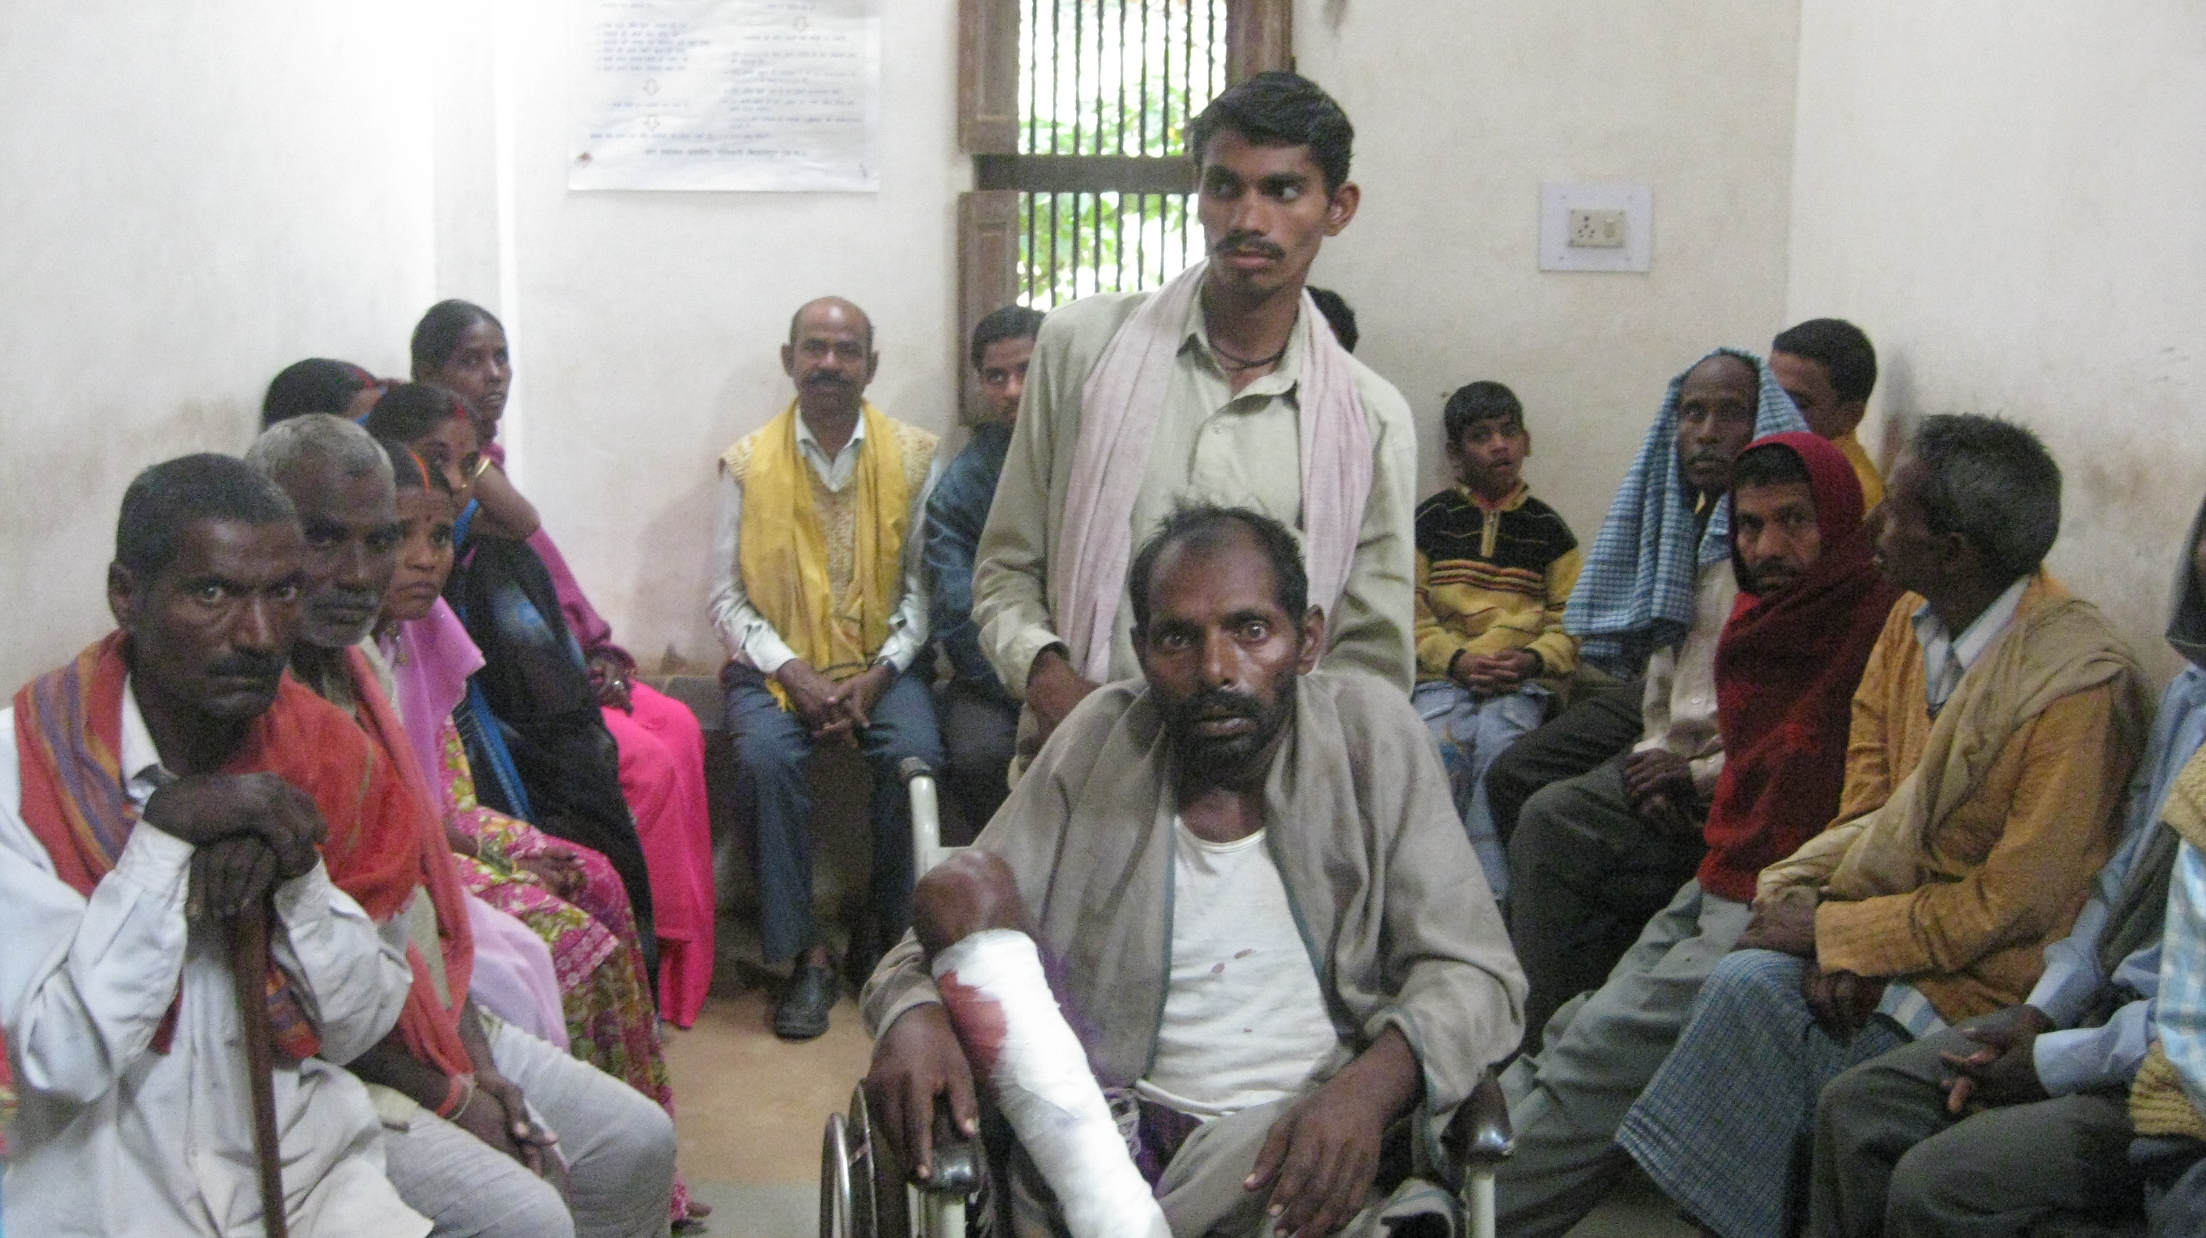

Patients waiting for a consultation at the clinic at Ganiyari

b. An inpatient ward with 30 beds and an operation theater complex (including 3 major operation theatres and a labour room) which has been functional since June 2001 and has provided high-quality surgical services to more than 15,000 patients.

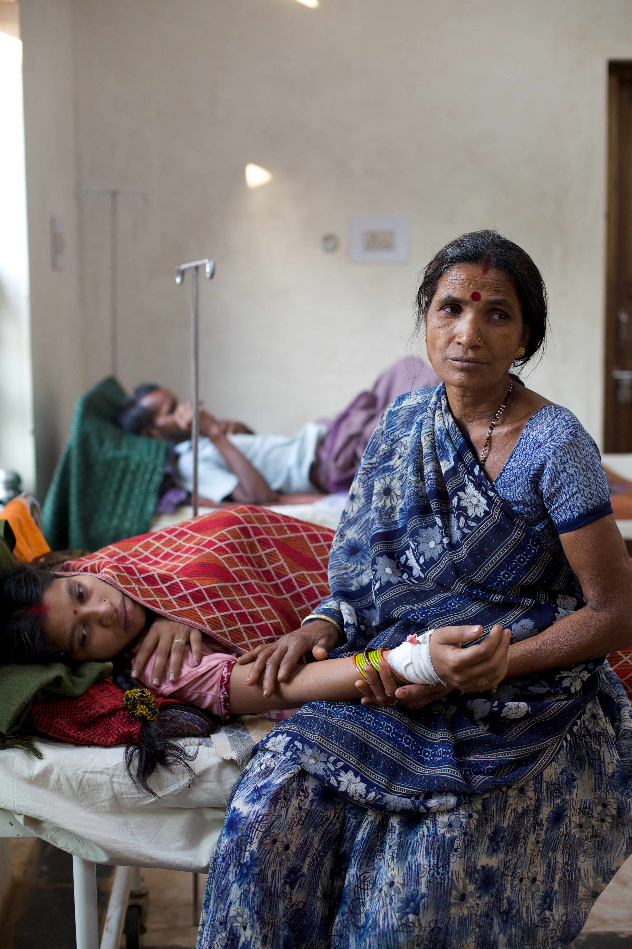
Mother and daughter in the new ward at the JSS clnic.

c. Three subcentres in three forest village clusters at villages Shivtarai, Semariya and Bamhni, about 45-85 km from Bilaspur town, which serve more than 150 forest and forest-fringe villages that are manned by two senior health workers each and are supported by doctor based outreach clinics every week.

3. Development, adaptation and validation of low-cost health care and diagnostic technology appropriate to application in rural areas- by village health workers, the community and by the public health centres. This has led to the creation of low cost diagnostic kits for diagnosis of anemia, urinary infections, pneumonia and sickle cell disease, among others. Also developed have been technology and aids for prevention of health problems like outbreaks of diarrhea, kits for detection of fecal contamination of drinking water, UV based disinfection systems which can run on cycle power and modular kits for safe conduct of delivery and post-partum care of the mother and child.

4. Appropriate field and clinic based operational, observational, and action based research into priority public health problems particularly childhood illnesses, tuberculosis, malaria and leprosy.

5. Running Training programs for other voluntary organizations and the government’s health workforce.

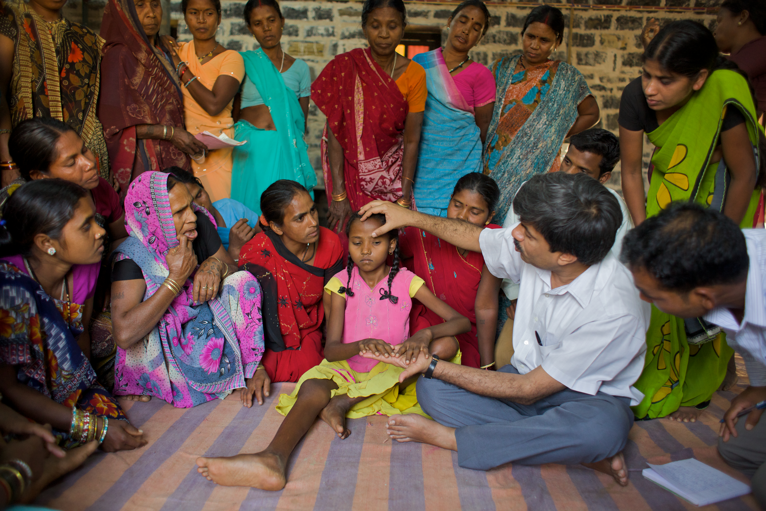
Learning about anaemia through clinical demonstration
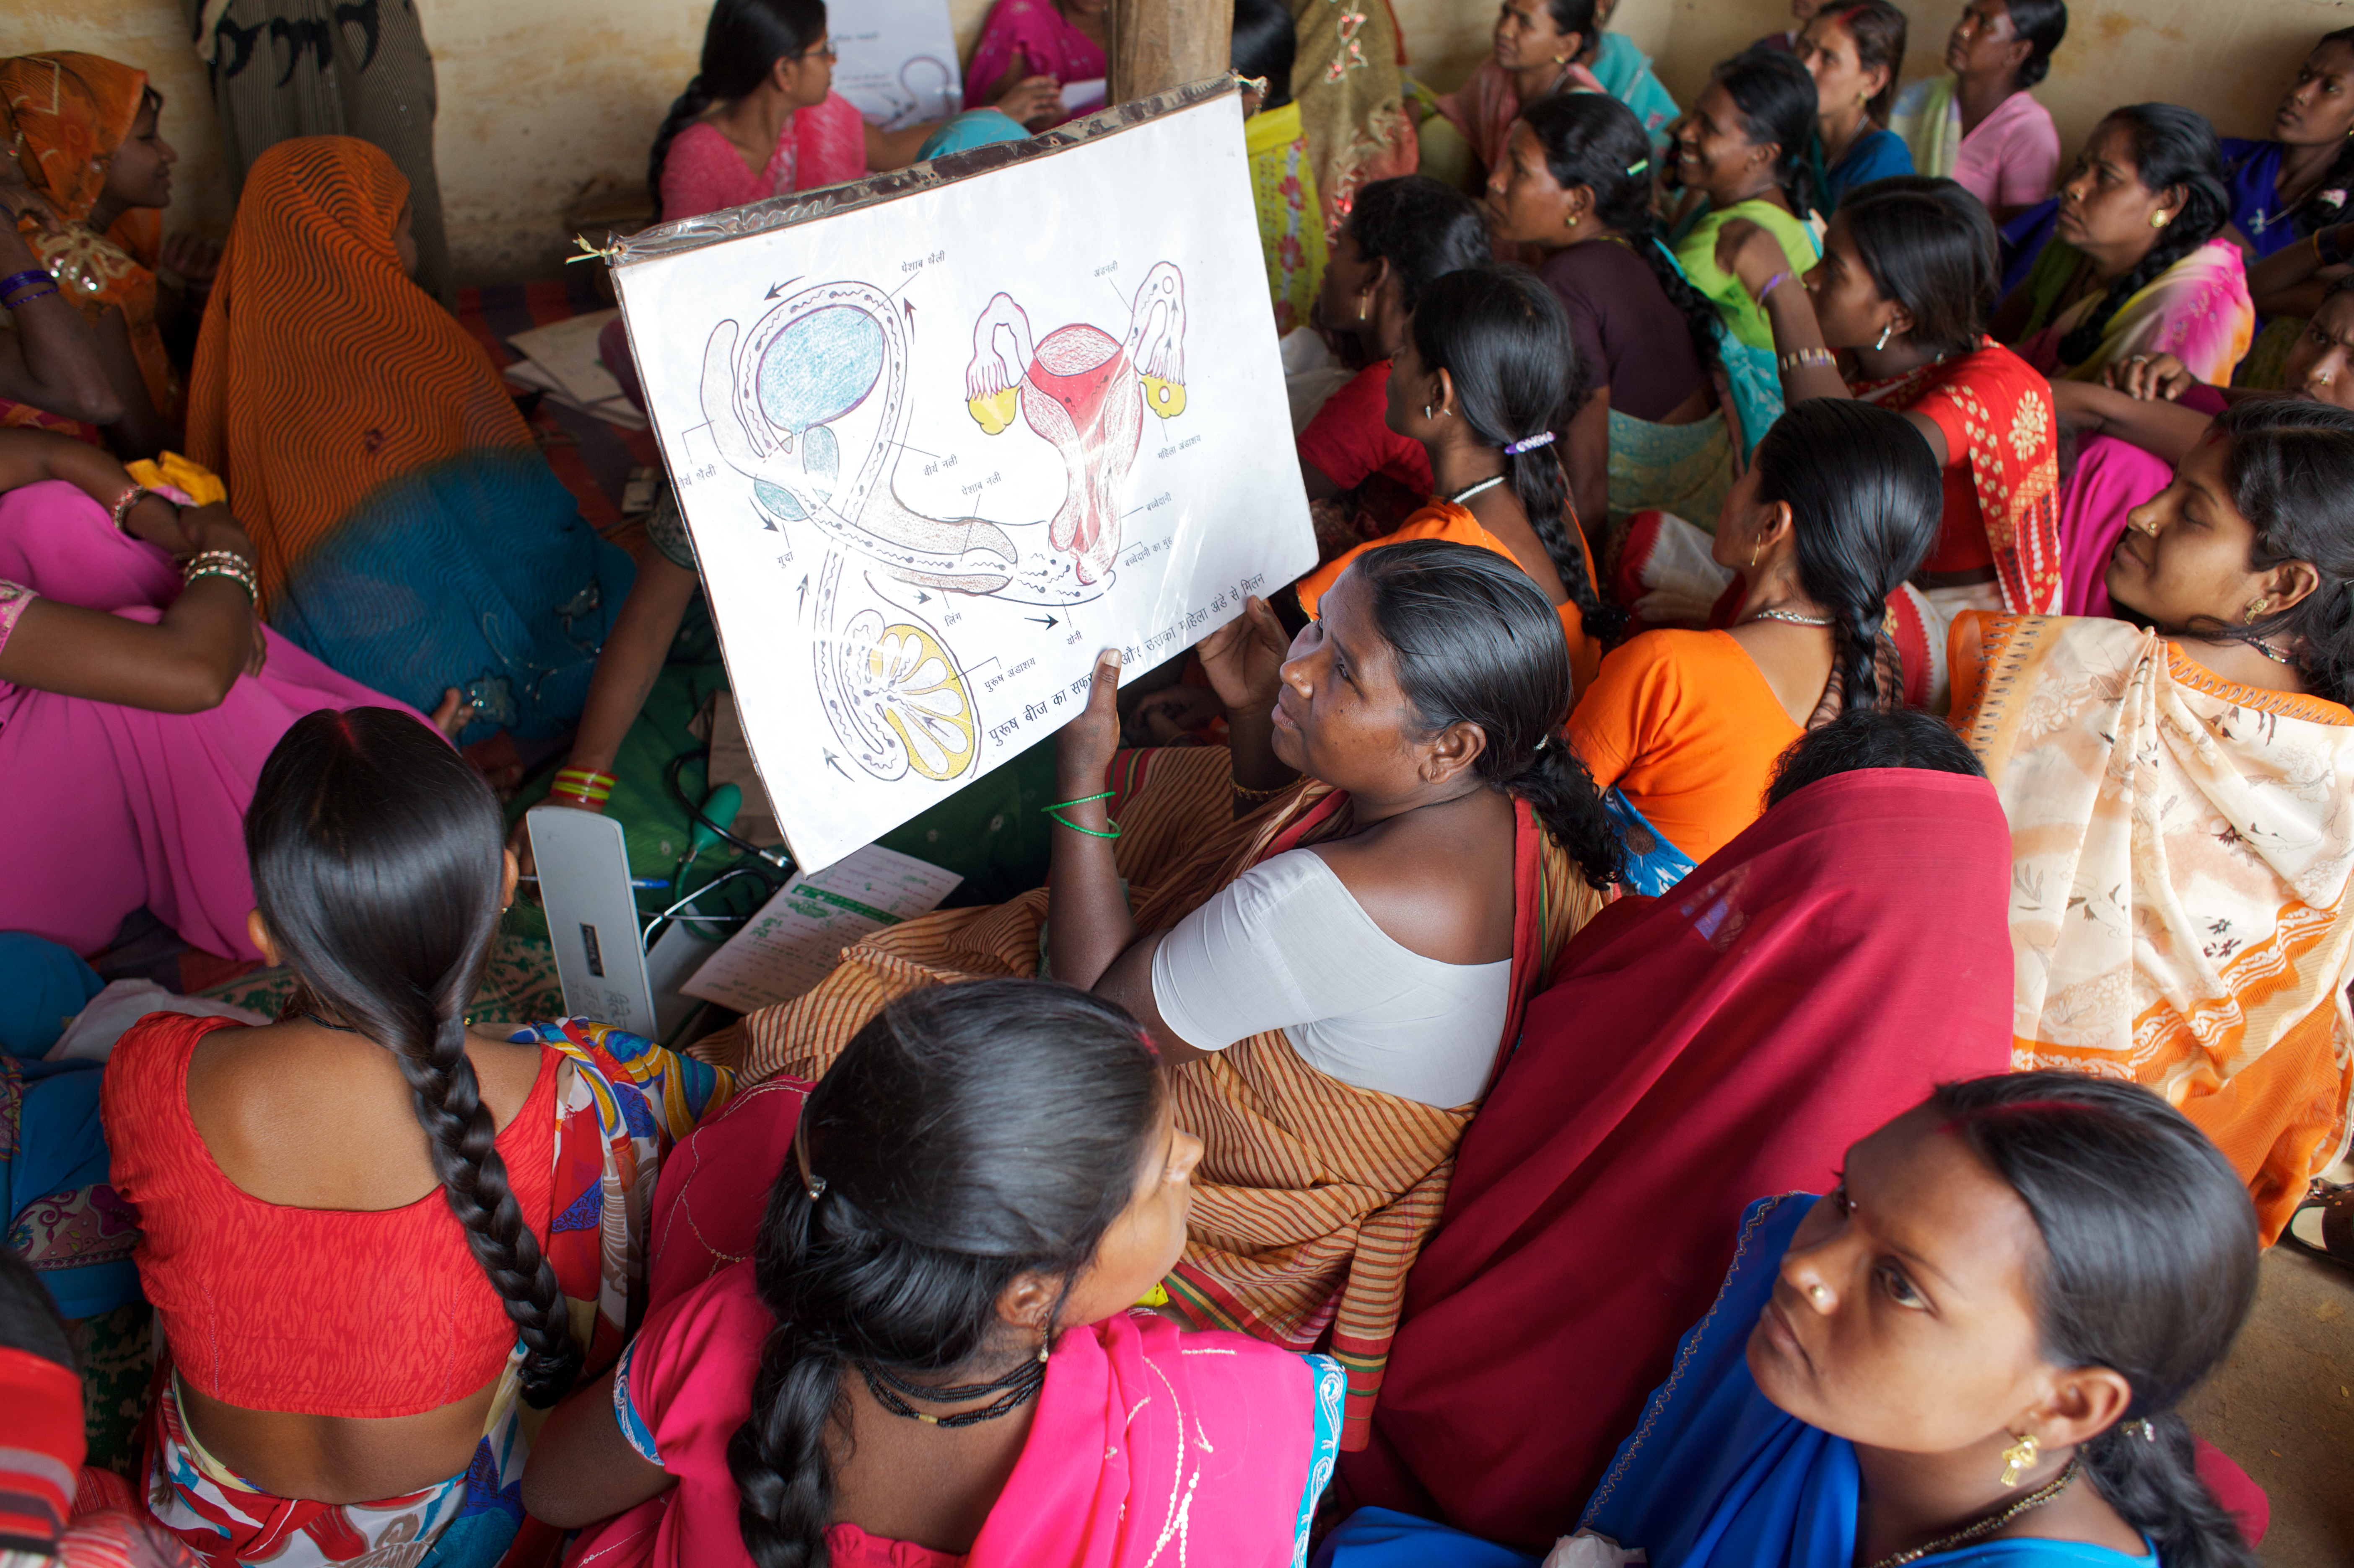
Pregnant women at an antenatal clinic in Semariya learn about conception and contraception

- Acting as a Technical Resource Group for the Government of Chhattisgarh, the Planning Commission, and other agencies.

- Advocacy. JSS has been involved in advocacy for primary health care and rational pharmaceutical policy, as well as highlighting the centrality of chronic hunger as India’s most important and persistent public health problem.

- Promotion of organic agriculture and practices capable of increasing agricultural yields like the system of rice intensification.

- Running a Phulwari program in which 61 Créches focusing on children under 3 years of age are being run with village support in the forest related villages with the aim of improving nutrition, and supporting the working parents.

The primary objective of all our activities has been to address the inequity in health. The strategy that we have chosen is of providing health care. Our focus is primary health care in the broadest sense of the word. And in the context of running a service delivery programme, we have tried to understand the causes of poor health of the people. Through good documentation and by conducting relevant observational research and by developing health related technology, we have tried to offer solutions to the technical, socioeconomic and operational problems. We try to offer these solutions through presentations in appropriate fora, through training and educational programmes, through publications and by lobbying with the state.
Over the last ten years, with financial support from many organizations and friends, we have been able to build up the spectrum of activities at JSS – based on infrastructural development, training human resources, asking the relevant questions, constantly learning and analyzing from work and sharing these learning in forums that address the health concerns of the rural poor. In this report, we discuss the present range of work briefly as well as recent developments in different activities at JSS.
Infrastructure development
The clinical services at JSS have undergone rapid expansion and up gradation in the span of a few years to cater to the increasing demand for comprehensive healthcare from a large population. From a health centre offering only outpatient services, basic laboratory services, a low-cost pharmacy and limited outpatient surgical procedures, it has evolved into a busy rural hospital providing clinical services to a truly diverse group of patients, outpatient and inpatient services, three major operation theaters and a fully equipped laboratory offering more than 50 different clinical pathological and biochemical tests apart from a microbiological facility unique in a rural setting. Over the last 2 years, we have been able to develop the following:
- We now have an increased bed strength of 35 beds since October 2009. While we have had a huge demand for admissions leading to over-admission of very sick patients in our 15 bed ward, we have only recently been able to make the new ward operational. A separate 6 bed tuberculosis ward is coming up rapidly.
- We now have a fully developed training centre that can support residential training of up to 50 trainees in various aspects of health care.
- The accommodation for nurses is also near completion.
- We have a 6 bed neonatal nursery also ready for use to add to the clinical facilities that the centre provides.
The Clinical Services at Jan Swasthya Sahyog
The clinical services at JSS which operate at the level of the hospital at Ganiyari, and the outreach clinics at village Semariya, Shivtarai and Bamhni, reach out to a population which suffers high levels of poverty, food insecurity, under nutrition and morbidity. Sixty one per cent of the people in the community where JSS has its outreach programme live below the poverty line. Thirty per cent of the population of the district is tribal, but given the forest related nature of the villages in the community health programme of JSS, more than 70% of the population served are tribals. Given the combination of factors mentioned above, adults and children suffer a high level of sickness. The low cost services of JSS operating both at the hospital and community level have helped unmask a large burden of illness which otherwise might have remained undetected or untreated. We have been enrolled as an RSBY service provider, thereby helping to further reduce health care expenses by poor rural families.

A. Infrastructure and Capacity:
- Professional team | 1 Pediatric and General Surgeon , 2 Pediatricians, 1 Gynecologist,2 Public health specialists, 2 Physicians, 1 Microbiologist, 1 ENT surgeon,1 Anesthetist, 1 Ayurvedic physician, 1 Visiting Radiologist, 1 Statistician (visiting), 1 Data Manager(visiting).  1 Nursing Tutor,9 Nurses, 2 Operation theater assistants, 6 laboratory technicians. 5 lab assistants, 4 lab attendants, 11 nursing assistants
- Outpatient services: | 6 consultation rooms, 4 emergency observation beds.
- Inpatient services: | Presently operational: 35 bed facility.
 | Constructed and to be made operational later this year : a nursery and Pediatric/Neonatal ICU; TB ward and isolation ward
- Operation theatres | 3 major, 1 minor operation theater: Fully equipped. All major surgeries either elective or emergency are performed- a wide range of surgeries on children including neonates and infants for various congenital malformations, hydrocephalus etc; thoracic surgeries including surgery for breast cancer, all major abdominal surgeries including a large number of curative/palliative surgeries for cancer, plastic surgery including cleft lip, palate, burn contractures.  1 post-operative recovery room, Centralized sterile supplies facility with a horizontal autoclave.
- Blood storage facility | In accordance with requirements of Government of India, the first to be sanctioned in Chhattisgarh.
- Laboratory | Fully equipped with microscopes, cell counter, biochemistry analysers, flame photometer, ELISA reader, coagulometer, electrophoresis apparatus, microbiology laboratory with laminar flow hood.
- Pharmacy: | One of the lowest cost pharmacies in India, with prices ranging from 10%-50% of the commercial / retail price of each medicine. Dispenses more than 300 essential medicines at the rural hospital and more than 100 medicines at the mobile clinics. Preferentially stocks quality generics, also procures good quality brands from reputed manufacturers at highly competitive rates and passes on the benefit to the patient.
- Training Centre: | Large training facility for different cadres of health workers, including doctors. Equipped with necessary projection equipment.
- Data management facility: | Central database of the community programme activities. Being developed are systems for computerizing inpatient and outpatient details; tracking of patients with chronic diseases etc.
- Ayurvedic services | Led by an Ayurvedic physician, also provides a wide range of herbal medicines.

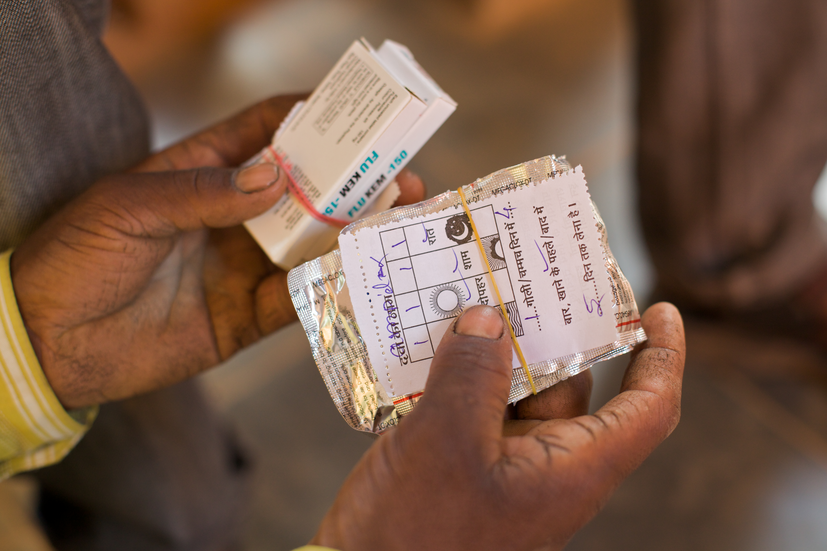
The low cost pharmacy run by JSS draws patients from long distances.

B. Patient numbers and patterns of illnesses.
There have been more than 3 lac consultations in the clinical services of JSS since its inception in February 2000. The OPD at Ganiyari is run on three days a week, while the outreach clinics are run by a doctor once a week at each of the three village clusters, at Shivterai, Semariya and Bamhni. Subcentre clinics are staffed by middle level health workers the rest of the week.
The figures for 2008 are illustrative of an average year:
Statistical overview of the clinical services of JSS in year 2008
- Total no. of OPD consultations | 40,155 consultations
- OPD at Ganiyari | 33, 752 consultations
- Outreach clinic at Semariya | 2769 consultations
- Outreach clinic at Bamni | 2132 consultations
- Outreach clinic at Shivterai | 1502 consultations
- Total number of inpatient admissions | 1286 admissions (short stay/overnight and long duration)
- Total number of surgeries | 1385 surgeries (major and minor)
- Total number of patients investigated in the laboratory services | 23285
- Total no. of investigations | 49,007 ( of which 44,560 were at the hospital in Ganiyari)

The above figures work out to an average OPD attendance of 216 per OPD at Ganiyari, and the average attendance at the outreach clinics run by a single doctor ranging from 28-54 patients per clinic day. The laboratory service caters to an average of 134 patients in a single clinic with an average of 285 tests per day. This attests both to the busy nature of our OPD service as well as the significant nature of the patients’ illness, a majority of whom require to be investigated for their proper diagnosis and management.
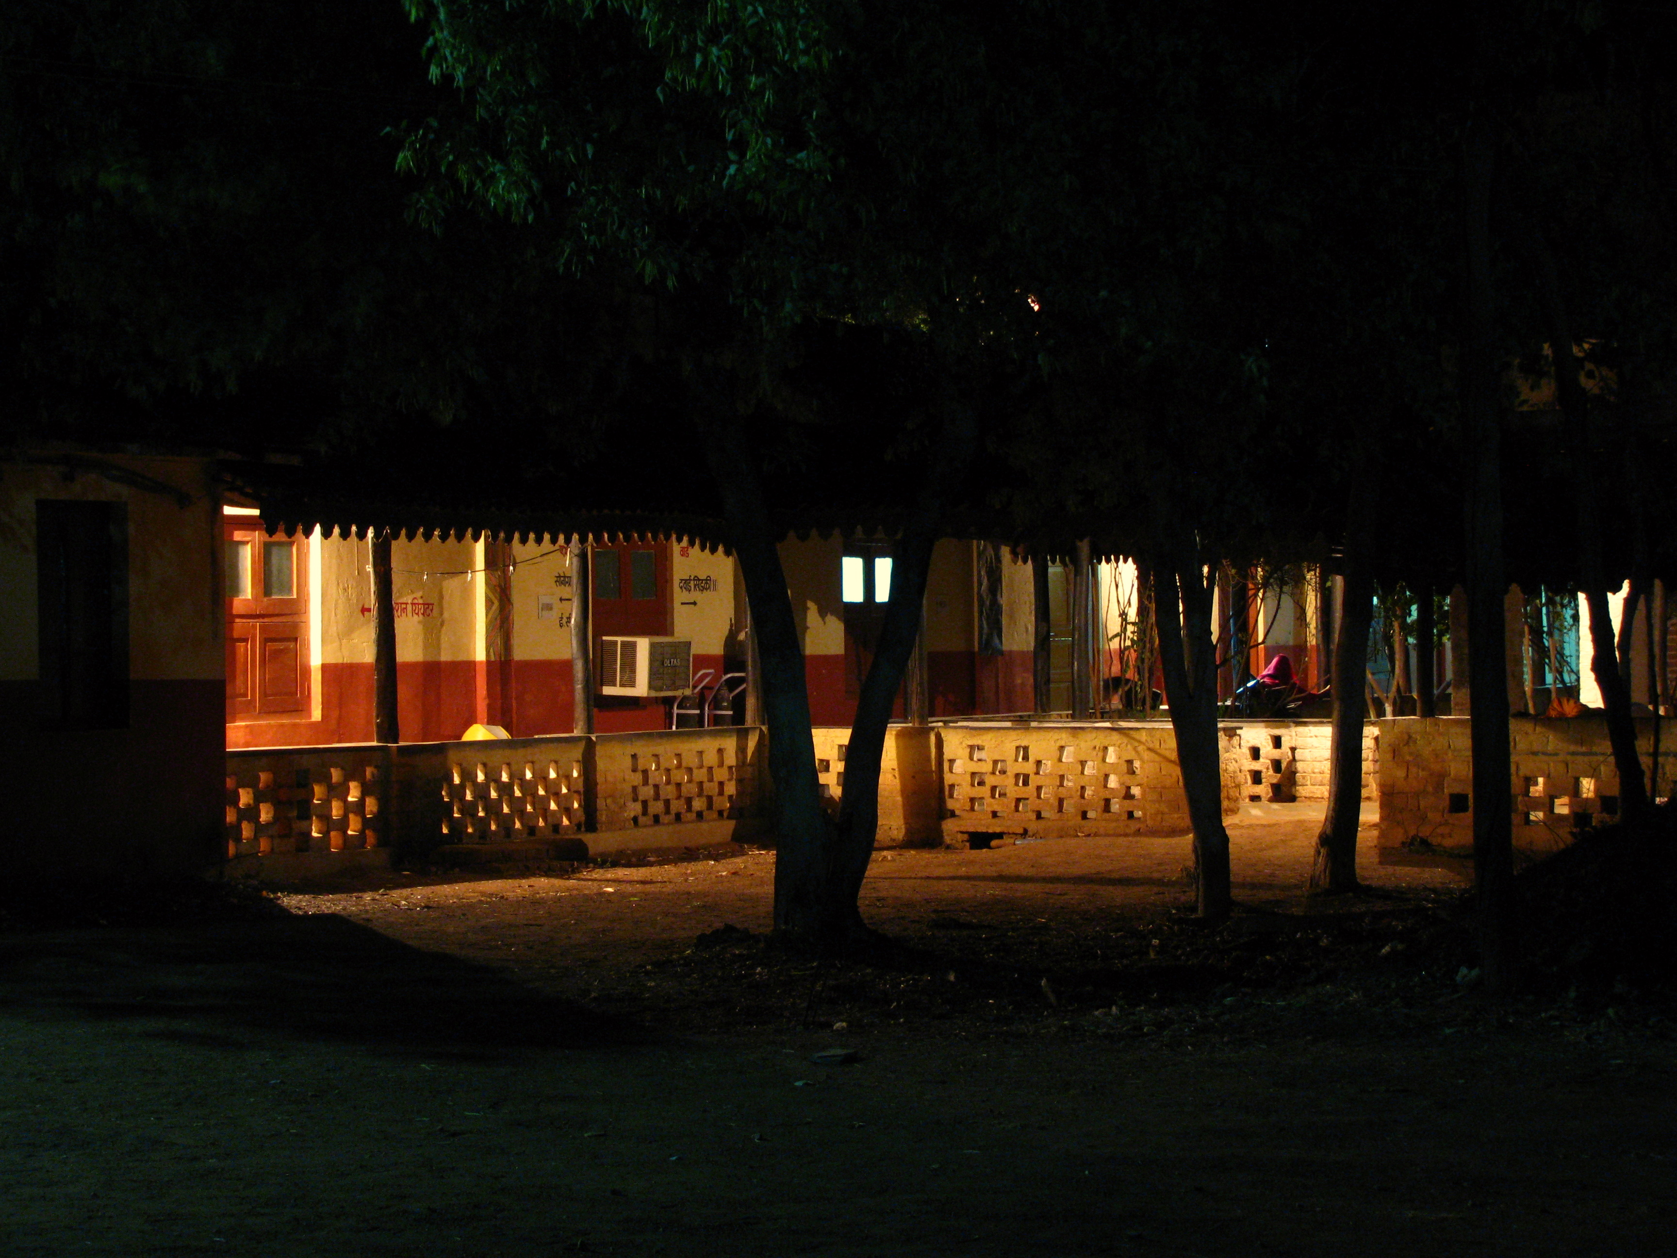
All quiet for a change – a view of the ward at night.

Patterns of illnesses seen:
The conventional classification of illnesses into communicable and non-communicable diseases is convenient although it fails to capture the diversity, complexity, and severity of diseases seen in a rural area. This is marked, as mentioned above, by high levels of poverty, undernutrition, and poor levels of access to healthcare.
A major part of the disease burden is due to infections and communicable diseases. The major problems seen in order of frequency are urinary tract infections, vaginitis, pneumonias, diarrheal diseases, falciparum malaria, tuberculosis, leprosy, pelvic inflammatory disease, serious soft tissue infections and empyemas.
The non-communicable diseases are a heterogeneous group comprising
- Deficiency diseases of which iron deficiency is the commonest.
- Respiratory disorders like asthma, chronic obstructive pulmonary disease.
- The whole range of surgical problems of the abdomen, gastrointestinal tract, genitourinary tract and the hepatobiliary system.
- Gastrointestinal/ hepatobiliary diseases like peptic ulcer, cancer of the stomach, cirrhosis of liver.
- Cardiovascular diseases like hypertension, rheumatic heart disease, and coronary artery disease.
- Endocrine disorders like diabetes, thyroid disorders.
- Mental illnesses, neurological disorders like seizures, diseases of the spinal cord, and degenerative disorders like Parkinsonism.
- Cancers of various types: the commonest cancers encountered are those of cervix, breast, oral cavity, stomach, colon and hematologic malignancies like acute and chronic leukemia, lymphoma.
- Renal diseases like nephrotic syndrome, acute and chronic renal failure.
- Genetic diseases : Of these the leading disease in our setting is sickle cell disease.
- Accidental injury, animal bites ( snake bites, and rabies still cause a significant number of deaths in rural areas).
- Substance abuse.
- Congenital malformations.
- Occupational diseases/exposures: we encounter patients with silicosis and organophosphorus poisoning.
- Urinary tract calculus disease, sometimes presenting with renal failure and associated urosepsis.
- Urinary outflow obstruction encountered most frequently in older males who may have undergone repeated catheterizations. Infants and children have obstruction due to posterior urethral valves.
- Burden of some of the illnesses seen in this year

Illness | New Patients
Tuberculosis | 550
Leprosy | 180
Hypertension | 400
Rheumatic heart disease | 75
Cancer | 300
Illnesses requiring emergency surgery | 250
Sickle cell disease | 75
Chronic Renal Failure | 80

The above mentioned diseases present in a variety of manifestations - from the acute presentation of a pneumonia, acute appendicitis, perforation of duodenal ulcer, to the sub acute presentation of a patient with tuberculosis, cancer of the stomach, to the chronic presentation of a patient with rheumatic heart disease, diabetes, or degenerative diseases like parkinsonism. The treatment required also varies – from a few days of antibiotic treatment for a pneumonia to 6 months of treatment for new patients with tuberculosis, to surgical interventions required for appendicitis, urinary tract stones or perforation, rheumatic valvular heart disease or spinal cord compression, to chronic illnesses which may require life long medication, such as diabetes, hypertension, bronchial asthma, sickle cell disease parkinsonism, seizure disorders and thyroid disorders.
The Community Health Programme: Strengthening Primary Care in an Underserved, Difficult to Access Terrain.
Over a period of ten years, starting from a cluster of 8 villages, we now run a community health program in 53 tribal villages in three clusters in Kota and Lormi blocks of Bilaspur district. These villages are located in forests or at the forest-fringe, and many of them lack access to all weather roads. The population served by the subcentres is around 75000 and by the village health workers around 26000. Over 72% of the population is adivasi, 7% dalits, and 19% backward castes.
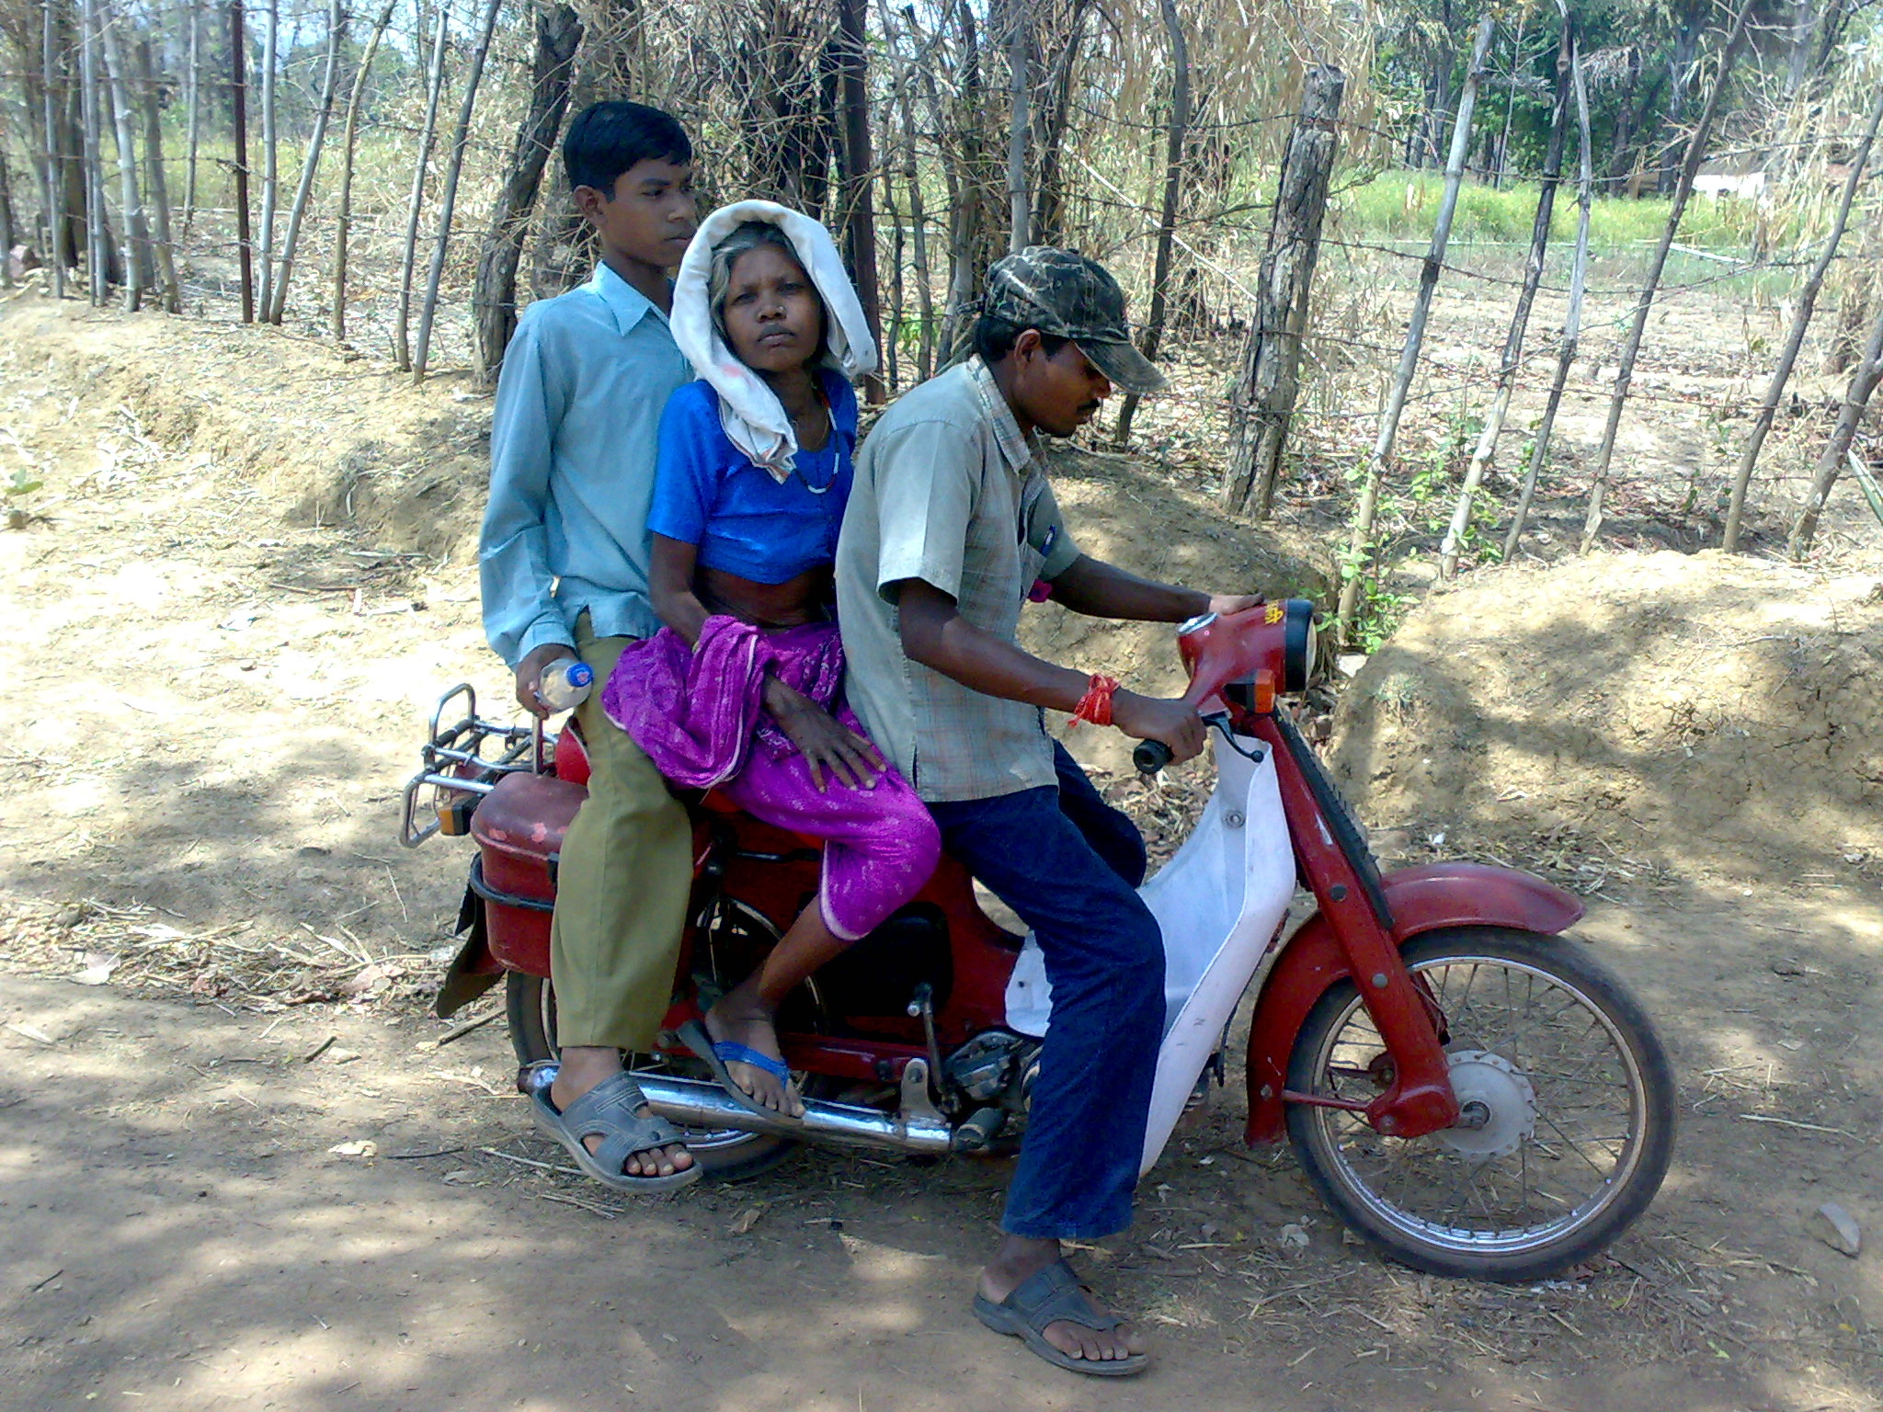
The motorcycle ambulance – a life saver in rural India where there is no public transport.
104 village health workers (VHWs) have been trained under the Village Health Programme. All the VHWs are women who have been selected by their respective villages, and work on a voluntary basis. They serve a number of critical functions essential for public health.
They have been trained to provide primary preventive and curative services for common illnesses such as malaria, diarrhoea, respiratory tract infections, and scabies, which are otherwise major causes of morbidity and mortality in young children.
The health workers take part in efforts to control under-nutrition, malaria, and tuberculosis and provide rational first contact care using 30 different kinds of medicines, and provide advice in terms of referral.

Most health workers are neoliterate but now function as paramedics. They prepare blood smears, measure blood pressure and can carry out a physical examination, including a vaginal examination. These village health workers also participate in community level initiatives to combat undernutrition, as well as communicable diseases notably malaria and tuberculosis.

Over the last two years, we have strengthened the second tier of our health programme- the senior health worker, also called the middle level health worker. A team of two workers each man the 3 sub- centres after receiving training for 9 months.
The main tasks of the middle level health worker include diagnosis of common illnesses including emergencies; management of these common emergencies and deciding about referral of those that she/ he cannot manage; manage a basic laboratory and be competent in performing investigations of common public health problems, and investigate reported outbreaks of illnesses in the area served, and plan their initial management. They also plan community control of common public health problems such as malaria; manage chronic illnesses such as hypertension, diabetes, sickle cell anemia etc after the therapeutic plan has been made by a physician, and supervise the work of the village health workers. They also plan and conduct health education in the community, and maintain clinical records and stock registers.

We believe that this cadre is capable of providing essential health care in rural areas, and is a replicable model for a 3 tiered community health care programme at the national level. The focus needs to shift from the doctor based strategy to “where there is no doctor” – supporting a middle level cadre of health worker. The village level health worker could continue to provide first contact care at the village level, counsel for proper and timely referral, be a link person and also prevent illnesses and organize people to raise demands from the health care services. Towards this end, we plan to continue to train senior health workers on a regular basis from community organizations in marginalized areas.
In order to address the massive problem of under nutrition in the under 3 child- arguably the biggest problem in health and nutrition that the country faces, we initiated the village crèche programme over the last 3 years. Setting up of a “Phulwari” which is aimed to provide a crèche facility to all children in the age group of 6 months to 3 years at the village level has been done after discussion with entire village communities. The Phulwari is run by a woman volunteer who is selected by the community. Supplementary nutritional food plus overall development inputs are provided in the crèches.
The following objectives are sought to be achieved through the crèche/ Phulwari programme
a) to provide a safe, secure and stimulating environment for young children 6 months to 3 years of age when their parents are out at work
b) to demonstrate to mothers that older infants (beyond 6 months) can consume and digest food other than breast milk, and that they thrive on it,
c) to prevent malnutrition among this age group and where children are malnourished, to improve their nutritional status and
d) to help older siblings (who have dropped out of school for the care of the younger child), to return to school.

At present, in April 2010, we have 895 children in 61 creches in 33 villages. Coupled with the larger child health care programme, the complementary feeding initiative seems to have remarkably reduced the infant mortality rates.
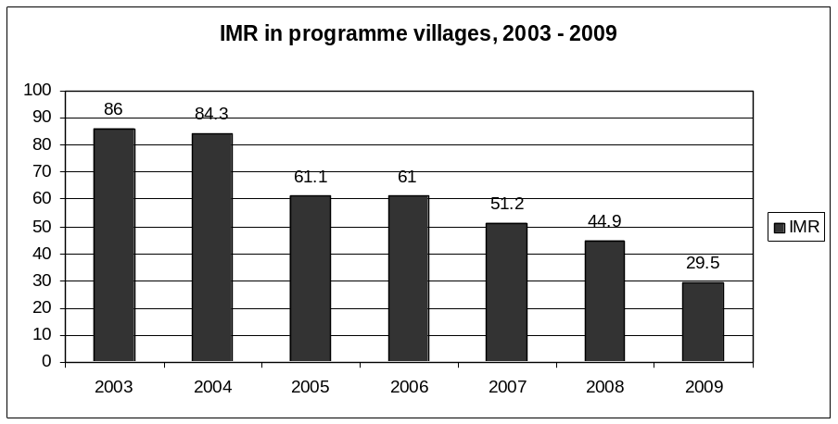
Supporting peripheral health workers
In order to improve the bidirectional communication between village health workers and the health system, we have initiated a cell phone based programme over the last year, a form of telemedicine. Though Mitanins/ Asha and ANMs handle a range of illnesses and the senior level health workers handle more complex emergencies, there are numerous occasions when they need to consult with a doctor. Trained health workers are capable of taking a proper history and conducting an examination, and when guided over the phone, they can make a correct diagnosis and provide treatment. Until the use of cellphones made it feasible, this consultation did not happen and thus decisions were taken by the peripheral workers on the basis of limited knowledge and confidence.
We initiated the use of cell phones for all peripheral workers so that they can consult their seniors (including specialist doctors) in their PHC and CHC as well as the faculty doctors at the local medical colleges, and thus make correct decisions.
“Celli-medicine” (cell phone medicine) has improved the quality of care at the most peripheral villages. They have allowed the health worker to share the complaints of a sick person and seek a second opinion on diagnosis and care from a more senior health worker or from a doctor; seek advise on dosage of drugs as well as urgency of referral; ask for transport like an ambulance from a more central health service in case of emergency; receive reports from the referral centre; and communicate with other workers for administrative issues and more efficient work planning.
Obstetric care
In order to improve obstetric care at the village level, we are working with traditional birth attendants by training them in skills in childbirth and child care. Thirty six traditional birth attendants in the forest cluster in the Achanakmaar sanctuary area are being regularly trained for the past 2 years. While the proportion of institutional delivery has increased from a low of 6% to a better but still poor 19%, the proportion of safe deliveries have increased significantly for women who come from these remote programme villages. At the referral centre, we now 60-70 deliveries every month, an increase perhaps mediated by the incentives being made available by the Janani Suraksha Yojana for institutional deliveries. The cesarean section rate is 20 %.
Organic farming for nutrition and health

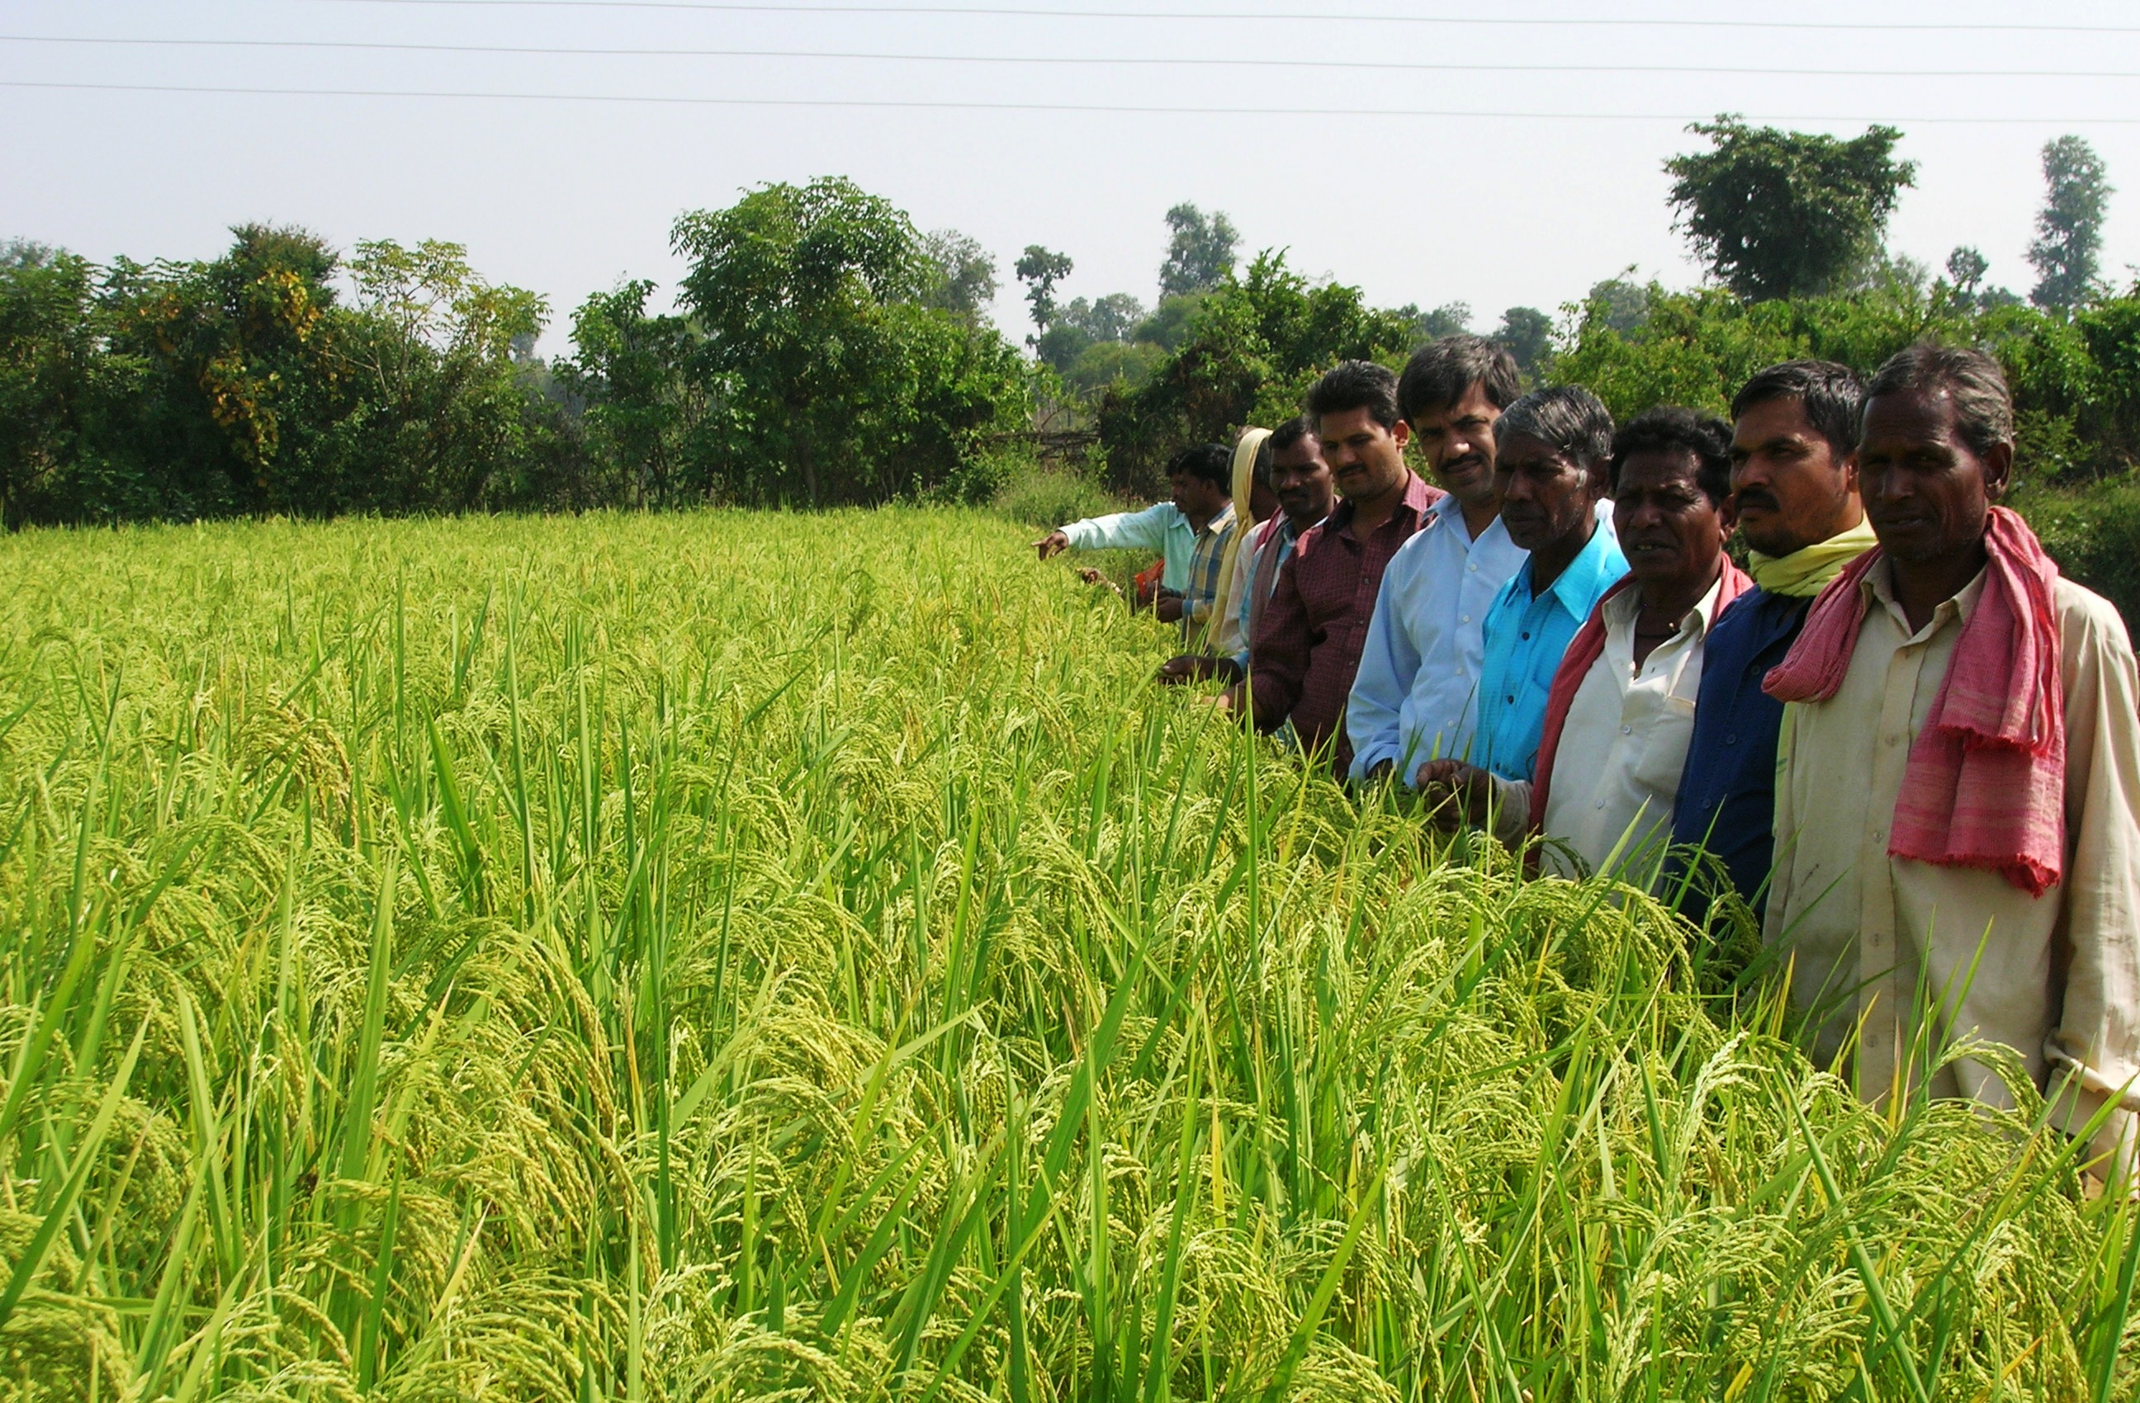
The focus in our agricultural initiative continues to be promotion of the System of Rice Intensification (SRI). This is a rice growing method, a package of agronomic practices which has the potential to double yields from the present low levels. In the past three years this technology has been widely tested by farmers in most rice growing areas in India; and found to have high potential. These developments forced the scientific establishment (Indian Council of Agricultural Research) and government to take note and recommend some policy support for its promotion. The Planning Commission had included SRI as a special package to be supported in the National Food Security Mission. Some states had taken pro-active policy measures to support SRI promotion, thus benefiting farmers and helping the spread of SRI. Our state, Chhattisgarh, is yet to make any concrete move in promoting SRI with direct support to farmers. This is despite many more civil society actors now engaged in promoting SRI in farmers fields throughout the state in the past two years. In 2009, about 100 farmers did rain fed based paddy cultivation using SRI, with promising results. We are moving in this direction by optimizing direct seeding practice of SRI in our experimental plots and some farmers’ fields.

Paddy crop following the SRI method of cultivation
Addressing Specific Diseases
In order to address specific public health problems, we have initiated and consolidated study, control and training programmes in chronic hunger, malaria, tuberculosis, leprosy, diabetes, hypertension, cancers (especially cancer cervix), sickle cell anemia, rheumatic heart disease, congenital malformations and animal bites. These programs have evolved on the basis of the understanding that has developed. While they have helped in streamlining the care of these illnesses, careful documentation has allowed us a better understanding of their true burden and the technical and operational issues in their management. Towards that end, we have organized consultations, participated in appropriate fora and published our experiences. We have also offered training in the management of many of these problems, besides sharing with our peers.
In the year 2009, we have seen 180 patients with leprosy and the numbers seem to be increasing each year, questioning the decision by the health department to disband the control programme. There is no change in the proportion of patients presenting with sensory or motor loss, which means that most patients are still being diagnosed very late. A significant number of patients are coming after Multi-Drug Therapy, due to either insufficient relief or actual deterioration while on treatment. The number of patients coming with inability to close their eyes completely (lagophthalmos) has actually gone up this year.
We see 550 patients with tuberculosis every year, which is almost one fourth of all patients that are seen in Bilaspur district. With almost 70% of them being severely undernourished and presenting with advanced and often resistant disease, treating them has been technically challenging. Sputum samples of patients are sent to the P.D.Hinduja hospital in Mumbai for culture and sensitivity tests. We currently have several patients with multi-drug resistant tuberculosis, and the cost for each such patient works out between Rs. 4000 to Rs 8000 per month on average, with treatment extending from 18 to 24 months. We have been engaging with the District Tuberculosis Programme as well as the central Tuberculosis Division on technical points with some success. We have also published a few articles on the subject to highlight the issues in tuberculosis control.
Malaria remains the most important problem that we see here. We have been able to reduce the transmission of malaria bringing the annual parasite index from a high of 33 to 6 over the last 8 years, and reduced deaths to almost zero. We have also documented the levels of resistance to chloroquine over the last 5 years, and showed that it is possible to study this even in a service delivery programme. We have shown that malaria in central India is a seasonal illness that peaks in the months of November and December thus requiring different control strategies than those conventionally followed. Over the last year, we have engaged with all stakeholders who decide policies in malaria control, in a two day consultation, and questioned the wisdom of some of the new policy changes in the national programme. We made presentations in various fora including the planning commission and the media. We have also offered training to voluntary agencies and the state public health system in its management. The response has been overwhelming.
We have succeeded in highlighting the unequal burden of deaths, expenses incurred and morbidity suffered by the rural and forest dwellers due to animal bites over the last 2 years. In the last year, we have established “animal bite care centres” at each of three sub-centres wherein village people can access timely emergency care for all types of animal bites. We have trained a large number of public health system personnel through seminars and training sessions as well as educated the community through radio and posters.
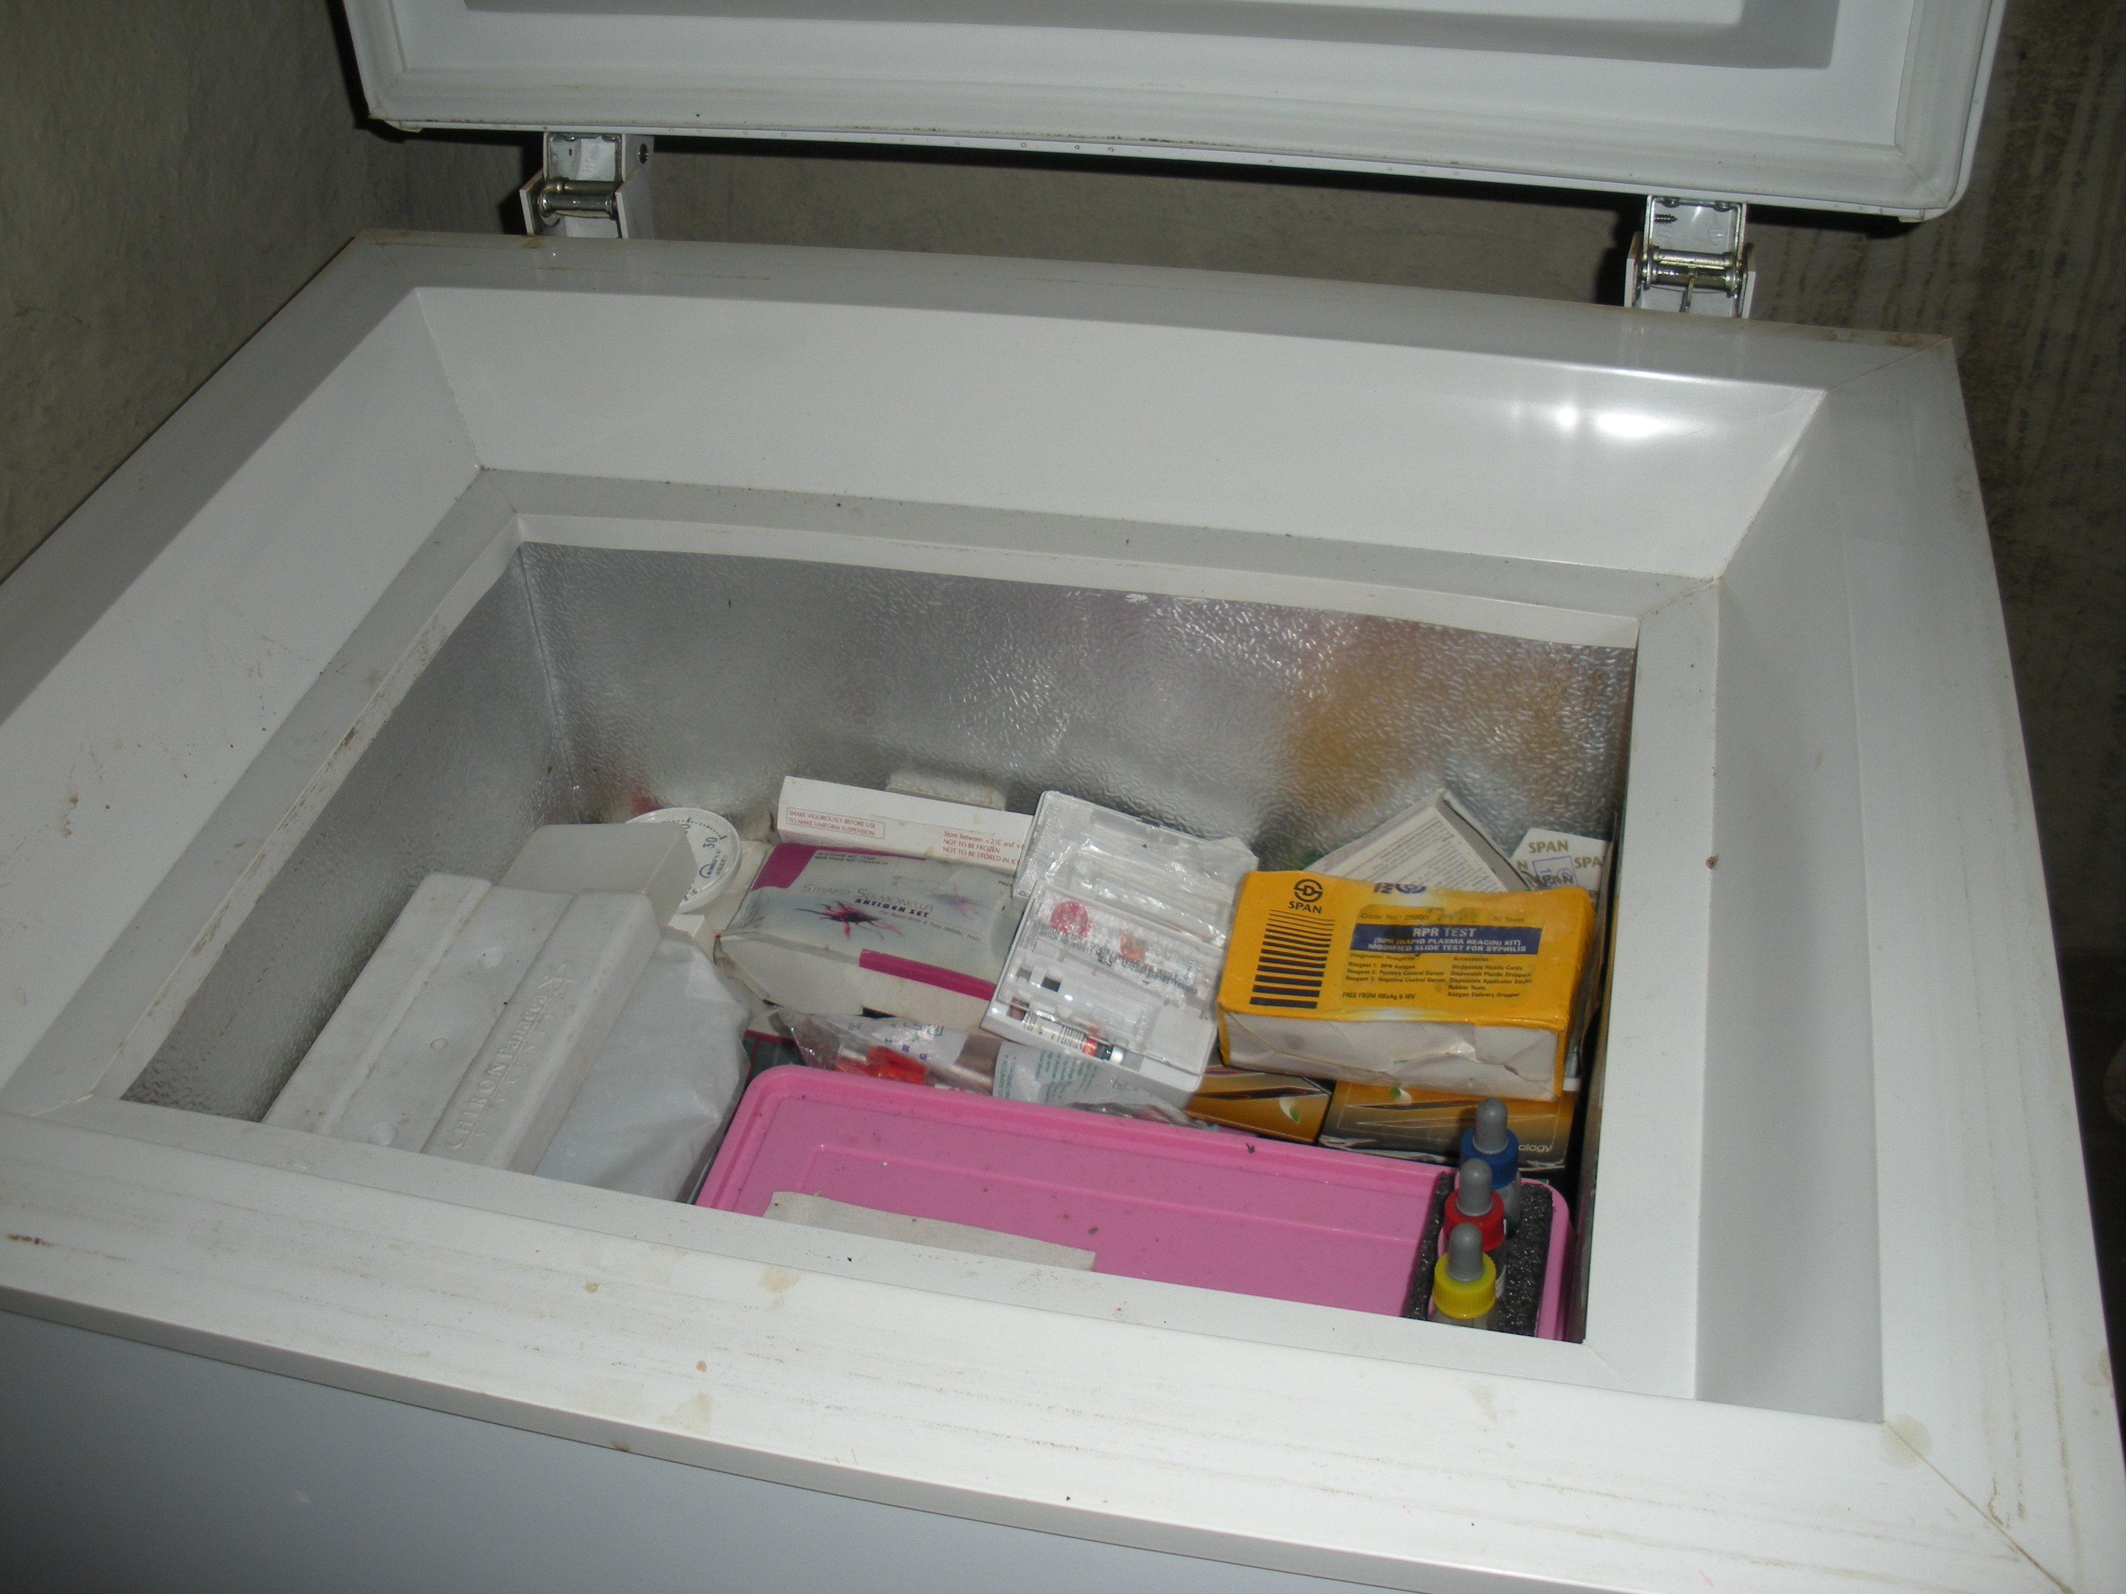
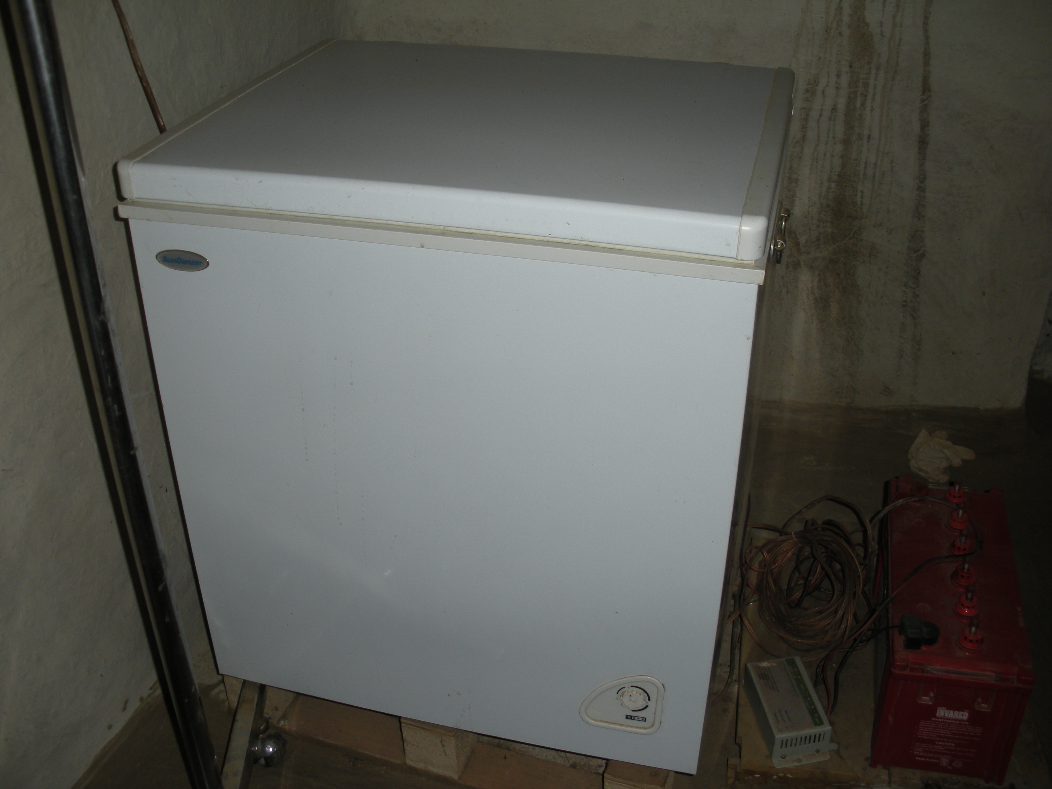

The solar powered refrigerator at Bamhni, storing vaccines including anti-rabies vaccine and anti-snake venom

We have been documenting the exact burden of problems like hypertension, diabetes, rheumatic heart diseases and sickle cell disease. Standardization of care is the other outcome of these initiatives.

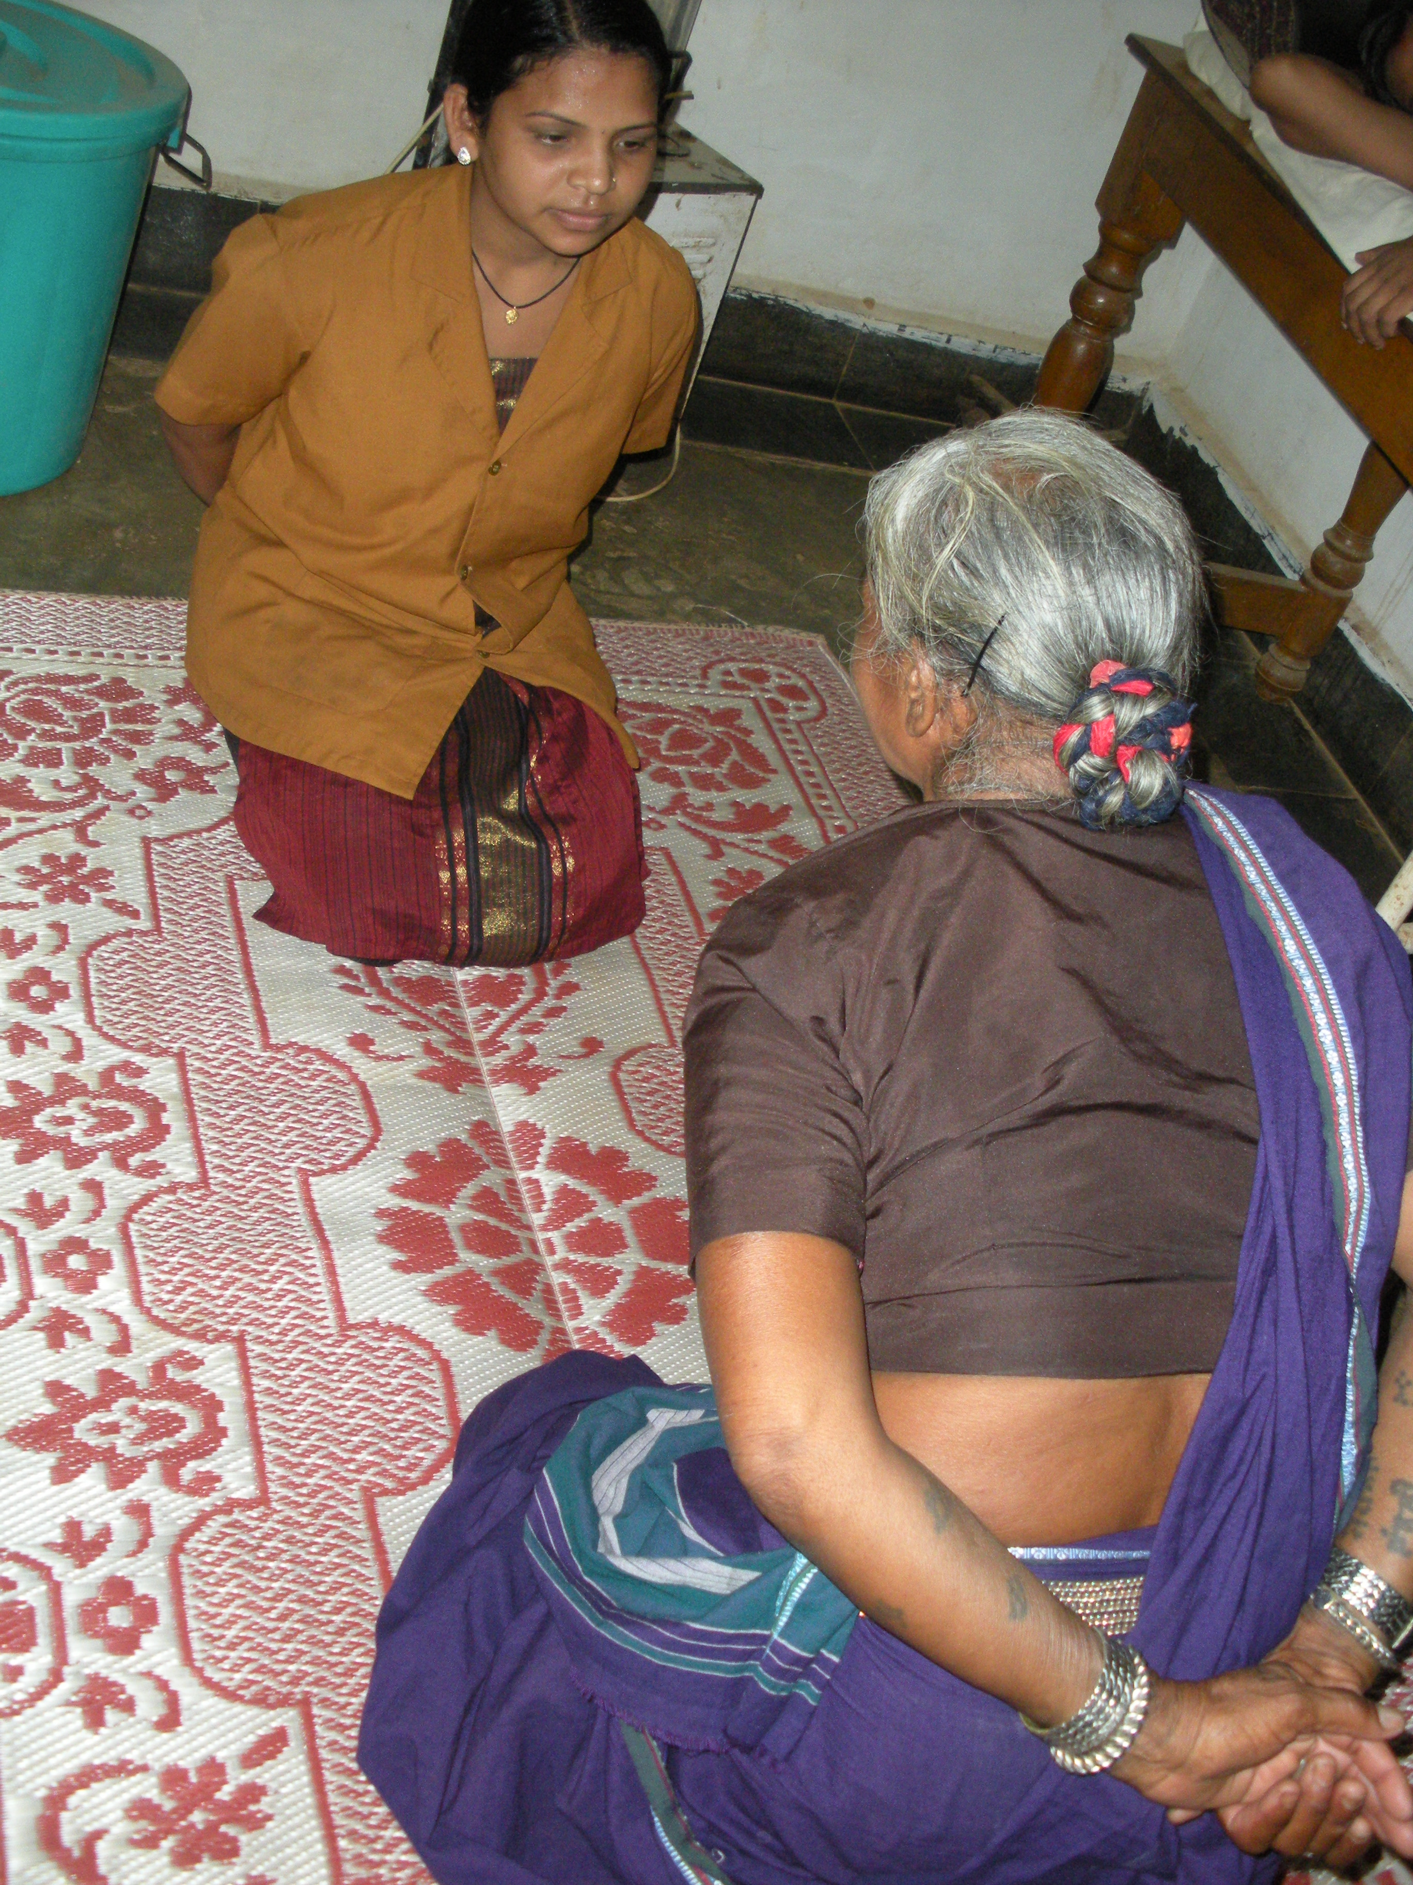

Preventive care: A nursing assistant teaching Shashakaasan to a patient.
The diagnostic laboratory
This is an integral part of the healthcare and community health program at JSS, providing diagnostic services to not only outpatients and inpatients, but also to the mobile clinics, and to the village health program. It is staffed by a medical microbiologist and qualified technicians and is well equipped to provide 50 different types of pathological, biochemical and basic microbiological investigations on different samples at extremely low cost. All reports are issued within four hours of sample collection with the exception of culture reports. The laboratory performs over 250 tests every day at the centre. Over 3500 blood slides from the slide transport system for malaria are seen every year, and the reports are sent out within 2 hours. A recent cost accountancy study done in October 2009 showed that the presence of the laboratory at JSS reduced the expenses that patients would have otherwise incurred on the overall treatment, by 75%.
The laboratory also has a blood storage unit that enables us to store and transfuse blood when required.
Research activities
Research in Developing Appropriate Technology
Jan Swasthya Sahyog's initiatives in developing and validating appropriate technology for health have been through improving access to diagnostic technology and innovating solutions for prevention of disease in rural areas. This has been taken up in response to the large unmet need for scientifically sound, effective and low-cost techniques and kits that are appropriate for application at the community level in rural areas for the diagnosis and prevention of disease. Jan Swasthya Sahyog has been involved in evolving such techniques over the past ten years. We are now in a position to offer such technology on a non-profit basis to other community based organizations or healthcare institutions working in rural areas.
Over the last ten years we have developed certain technologies that help the community in improving their own health such as a low-cost test for the detection of fecal contamination of drinking water, an ultraviolet light based water purification system, which can be used by village communities, mosquito repellent oil and cream containing 5% dimethyl phthalate and diethyltoluamide, insecticide treated bednets of various sizes, as well as easily affordable sanitary napkins. We also have been able to evolve a presbyopia support programme called Naina- Chaleesa wherein women and men above the age of 40 can choose spectacles that suit their needs of near vision, from the collection that their village health worker or their nearest health centre has, without going to an optician, thereby avoiding unnecessary expense and also demystifying medical technology.
We have also developed a first aid kit for villages that is a collection of all the material that is necessary for common illnesses and injuries including animal bites. We have also developed modular safe delivery kits that look at the needs of the delivering mother, the newborn and the midwife. The other development is in the appropriate use of public transport such as the slide courier system for early diagnosis of malaria that allows prompt treatment thereby saving lives and expense.
Other technologies developed or adapted include devices that are useful for the village health worker to diagnose and treat people. They include weighing machines, stadiometers (for measuring height and length) and thermometers that are inexpensive and yet accurate, teaching stethoscope, easy to use blood pressure instruments and a spacer device for use by patients with asthma. A breath counter has been developed that improves the diagnosis of pneumonia in the under 5 year age group. A simple test to document the severity of anemia using a copper sulphate based densitometry and sputum concentration test for better microscopic diagnosis of tuberculosis has also been developed. Other developments include development of a nutritional formulary that includes calcium supplements and a mineral mix for managing severe under nutrition.
Still other achievements in this field have been the development of a low-cost electrophoresis system for the definitive diagnosis of sickle cell anemia, which is prevalent in this part of the country.
Among the recent developments has been the assembling of a solar powered refrigerator that has been commissioned at the Bamhni sub centre to be able to preserve the antisera and vaccines for snake and suspected rabid animal bites. This is almost a first that has been done in primary health care. This refrigerator has been made at a cost of Rs 40,000 only, whereas the cheapest in the market is available for not less than three times this cost.
In this year, we have also commissioned an oil mill to extract edible oil from locally available oilseeds at Ganiyari. This ‘tel peraai ghaani’ serves the people of the villages whereby farmers can come with their oilseeds they either grow or gather and get oil extracted at no cost and take back the pure oil and the oilcakes if they wish . Previously, farmers had been selling their oilseeds to middlemen at very cheap rates, thus depriving them of both a proper income as well as oil that would make a most significant addition to their nutrition. Till 2009, the average per capita oil consumption among people was 18 grams per day, way below the recommended intake of 40 grams per day. This is due to exorbitant market prices as well as a and lack of availability of oil locally.
Addressing other research questions
We have been trying to address a few research questions as part of an action research strategy. These emerged as public health questions during the course of the service work, and we then used either careful documentation of case series or case control designs in addressing these questions. Only in a few situations did we employ an intervention design. Some of the questions that we have addressed are as follows.

- What is the prevalence of chloroquine resistance in falciparum malaria in Bilaspur? Case series
- What is the sensitivity and specificity of various antigen based malaria rapid diagnostic kits in comparison to thick smear microscopy? Diagnostic evaluation
- Is it cost effective for a community malaria control programme to employ a subsidized bed net based strategy? Intervention trial
- What is the diagnostic accuracy of a breath counter in the hands of the health worker in the diagnosis of pneumonia in children? Diagnostic evaluation
- What is the advantage of providing preventive treatment in the under 5 childhood contacts of adult patients with pulmonary tuberculosis? Case series
- Does a ‘chiraita’ based herbal preparation prevent falciparum malaria? Intervention trial
- Why do some people with tuberculosis stop treatment prematurely? Case control design
- Are people who migrate seasonally at higher risk of developing tuberculosis in subsequent 2 years? Case control design
- What is the duration of effect of a mosquito repellant oil based preparation? Diagnostic evaluation
- Is there a correlation of malaria seasonality with the nutritional status of people? Community survey
- What volume of repellant oil does one need to apply in one application on the exposed parts of the body for it to be effective? Observational study
- What is the prevalence of hypertension among adult women in the community and does it correlate with the nutritional status? Community survey
- What is the health expenditure incurred by patients who attend the clinic at Ganiyari, and what is the level of indebtedness among them? Survey

Advocacy Initiatives at JSS

JSS has tried to intervene in influencing policy and practices where possible in issues of primary health care of the rural poor. The main areas of advocacy have been in the
  - Drug pricing, procurement, weeding out irrationality, and the listing of essential drugs
  - Diagnosis, treatment and control of malaria in the public health system and the community
  - Treatment strategies, choices and diagnostic strategies in tuberculosis treatment
  - Antiretroviral therapy care availability for HIV positive people at the state level in Chhattisgarh
  - Better PDS and food availability and supplemental oil in PDS
  - Access and quality issues in primary health care- advocating universal health care and a package of health care that looks at all the needs of the rural poor people
  - Need to reinstate a proper leprosy treatment and control programme
  - Radiotherapy facilities in central and northern Chhattisgarh
  - And finally, to have a special programme for the under 3 child- especially to address the complementary feeding needs
  - Advocacy for nutrition supplements for patients with tuberculosis, leprosy, HIV and severe anaemia.
  - Hemodialysis at the medical college in Bilaspur and select public hospitals in rural Chhattisgarh

Training and Technical Resource activities

Jan Swasthya Sahyog is a multi-disciplinary group with an academic and teaching background. One of our aims is to provide training and other inputs to other voluntary organizations, particularly in Chhattisgarh. We have responded to several requests from grassroots organizations, as well as the government’s health system for training various levels of health care workers in health care and related issues. In the year 2009, we have trained over 250 health professionals and workers from 20 people’s movements and NGOs, the public health system of various parts of Chhattisgarh and the states of Jharkhand, Madhya Pradesh, Orissa, Assam, Manipur, Maharashtra and Andhra Pradesh in various aspects of primary health care. The trainees included doctors, nurses, laboratory technicians, community organizers, village and cluster level workers and health care administrators. This is in addition to the ongoing training of our own field workers including health workers, crèche workers and traditional birth attendants. We have also trained a first batch of nursing assistants this year.

A glimpse of the training activities in 2009

Date | Number of trainees | Organization | Location | Subject
January 15-18, 2009 | 5 | PRADAAN, Sundarpahari, Jharkhand | Ganiyari | Malaria control, community health programme
April 2009 | 1 | Suman Baddam, Internal medicine resident, USA | Ganiyari | One month placement for training in primary care
May 21 – 31, 2009 | 10 | PRADAAN, Sundarpahari, Jharkhand | Jharkhand | Identifying mosquito breeding sites, MMN preparation, distribution, use.
May 15-25, 2009 | 5 | 3rd year medical students, Christian Medical College, Vellore. | Ganiyari | Secondary hospital posting 10 days
June 1-30, 2009 | 10 | RAHA, North Chhattisgarh | Chhattisgarh | Basic Laboratory techniques in malaria and Tuberculosis
June 2009 | 1 | Jasmeen Dara, pediatric resident, USA | Ganiyari | One month posting in paediatrics
July 6 – 8, 2009 | 7 | Don Bosco Social Welfare Centre, Tamenglong, Manipur | Ganiyari | How to run a village health worker based programme
January, 2009 | 1 | Carolina Pena, Pediatric resident, US | Ganiyari | Clinical posting
July 31 – August 28,2009 | 2 | Sabine and Eva Damm, Medical students from Marburg, Germany | Ganiyari | For clinical posting
September 16 – 18,2009 | 25 | FEMALE, Jharkhand | Ranchi | Child health and nutrition
August 1 – November 1, 2009 | 15 | In-house at JSS, girls selected from villages in Bilaspur district | Ganiyari | Nursing Assistants
November 21, 2009 | 20 | School teachers, Eklavya, Indore | Indore | Malnutrition
November 22, 2009 | 18 | Eklavya, Dewas | Dewas | Malnutrition
July – August, 2009 | >200 | District and block medical officers, ANMs | Kota block, CMHO office Bilaspur | Snake bite
September 2009 | 2 | Recruits of the Tata Administrative Services, Mumbai | Ganiyari | One month rural posting
April – Dec, 2009 | 50 | Doctors, nurses, health administrators | SIHFW, Raipur, Chhattisgarh | Emergency Obstetric care, control of falciparum malaria

Activities as a Resource Group
On the basis of the learning from the community health programme, JSS serves as a resource group in training as well as making policy and practice interventions in both government and nongovernmental levels.
- At the Chhattisgarh state level, we are members of the State Health Resource centre, the State Institute of Health and family welfare and the implementation group for effecting health sector reforms in the state. JSS is also a part of the Jan Swasthya Abhiyan, the People’s Rural Health Watch and the Community Monitoring group for the NRHM.
- Presentations on policy interventions have been made in issues of drug pricing , use of rational issues have been made to parliamentarians group, special parliamentary committees, All India Drug Action Network, consumers groups, medical representatives’ federations, medical colleges faculty and students at AIIMS, New Delhi, GMC, Nagpur and CMC Vellore.
- Presentations have been made on policy issues to various professional bodies such as Indian Cardiac Society, ICMR and the Indian Academy of Pediatrics.
- The Planning Commission, Government of India refers to JSS as a special resource group for making Health care affordable at low cost in its XI plan report.
- The Department of Science and Technology, New Delhi considers JSS as a resource group for Appropriate Technology in health care.

Consultation on falciparum malaria control
A consultation to discuss issues related to falciparum malaria control in India was convened by Jan Swasthya Sahyog at Ganiyari on 19th and 20th February, 2009. It was felt necessary to discuss the new recommendations for the control of falciparum malaria that have been made by the NVBDCP in order to develop a common understanding of the issues involved, and to build support for reducing the burden of malaria in central India.
These issues included the preferential use of Rapid Diagnostic kits (RDTs) instead of strengthening the microscopy services to diagnose falciparum malaria; the use of Artesunate Combination Treatment (ACT) for all cases of falciparum malaria; the withdrawal of chloroquine chemoprophylaxis in pregnancy in women in endemic areas; use of only long lasting bed nets as the mainstay of control strategies in the programme; the district hospital being the minimum level of health care delivery for treatment of severe malaria. Finally to deliver all the aspects of malaria control at the community level, the ASHA would now become the main provider of services - in fact the expectation is that these new initiatives will infuse new energy into the ailing public health system.
The consultation was held to exchange views and information, share experiences and discuss several technical, operational and governance issues. The group had representation from a variety of people working with malaria in the states of Chhattisgarh, Orissa, Jharkhand, Madhya Pradesh, Maharashtra, Gujarat, West Bengal and Assam. They included Directors from NVBDCP, New Delhi; social activists from NGOs working in malarious areas ; representatives from international agencies like the WHO, World Bank, UNICEF, Medicine Sans Frontiers MSF and Drugs for Neglected Diseases initiative DNDi ; experienced clinicians treating malaria patients in the poorest parts of the country ; State Health Secretaries / Commissioners, State Malaria Officers, Public Health experts , scientists from NIMR & NVBDCP and teachers of Medicine from academic institutions.
Several recommendations were made by the group and these were forwarded to the NVBDCP for consideration. Subsequently, The Planning Commission requested JSS for a presentation of the issues raised and discussed at the abovementioned consultation, and a meeting was held on 13th May 2009, where the Health Secretary, Jt Secretary (Health), as well as the Director and Jt Director NVBDCP, Director NIMR, representatives from the World Bank, WHO and UNICEF were present. A representation was also made to the Joint Secretary in the PMO regarding the issue of malaria chemoprophylaxis in pregnancy.
Workshop on comprehensive HIV care at primary and secondary care levels in Chhattisgarh.
A workshop on“Comprehensive HIV care at primary, secondary care levels in Chhattisgarh: Facing the challenge, scaling up the response” was held on the 7th and 8th of May 2009, at the JSS Health Centre at Ganiyari.
Participants in the workshop included the programme managers of CG State AIDS Control Society, the doctors posted in the PHCs and CHCs of Bilaspur, Jangir-Champa, and Korba districts, and the District Hospital Bilaspur, and last but not the least, the people living with HIV/AIDS themselves represented by members of the Chhattisgarh Network of Positive People (CGNP+).
The primary focus was on the people who are affected by the virus, and representatives of the positive people’s network were present throughout the workshop and participated actively in it. The epidemiology of HIV infection was discussed, as well as the scale of the illness in the country and in the various states, especially Chhattisgarh. Clinical manifestations of the infection, including modes of transmission were also discussed. There were sessions on diagnosis of the disease and counseling, as well as evaluation of a person with HIV disease at primary and secondary levels. Sessions on prevention of infections in HIV affected people, treatment of opportunistic infections, tuberculosis in HIV patients, and anti-retroviral therapy were also there. There was focus on care in special groups like pregnant women and in infants, including prevention of parent to child transmission of HIV.
The concluding discussion was encouraging in that most participants felt that diagnosis and management of HIV infected patients, including opportunistic infections in these patients, is possible at primary and secondary care levels in the public health system.

Financial support for JSS activities
The work of Jan Swasthya Sahyog has been supported through the years by generous contributions from individual well-wishers, as well as from grants from various Trusts and organizations. Our work would not have been possible without this support. Major funders of our work in the year 2009 have been the following:
AIIMSONIANS of America (AOA), USA; Association for India’s Development (AID), various chapters, USA; Chhattisgarh State AIDS Control Society, Raipur; Hospital for Indien, Germany; Indo-American Cancer Association, USA; Jiv Daya Foundation, USA; Letz Dream Foundation, Gurgaon, Mumbai; MG Charitable Trust, Mumbai; Oxfam India Trust, New Delhi; Sir Dorabji Tata Trust, Mumbai; Sir Ratan Tata Trust, Mumbai; SPA Education Foundation, Mumbai; State Bank of India, Bilaspur; State Health Resource Centre, Raipur;
Besides these, we have received donations from many individuals in the past year. Several of them have contributed more than once and through the years and supported us monetarily as well as morally. Some donors have chosen to remain anonymous and so are not mentioned in the list below.
Jan Swasthya Sahyog gratefully acknowledges the support it has received from everyone.
Individuals who have contributed in the past year to Jan Swasthya Sahyog’s work.
Mr Prem Prakash Jain, New Dehli; Dr GNV Ramana, New Delhi; Mr Vijay Prasad Sharma, New Delhi; Dr Siddharth Kothari, New Delhi; Dr Tapas Mondal, Ontario; Ms. Anjani Kochak, New Delhi; Ms Padma Prakash, Mumbai; Mrs Priya Bajaj, Bilaspur; Mr Gurmit Singh Arora, Bilaspur; Ms Priti Chouhan, Bilaspur; Mr Vikram Singh, Bilaspur; Mr Saroj Kumar Sahu, Bilaspur; Mr Harish Kedia, Bilaspur; Mr Arjun Agarwal, Bilaspur; Mr Brijmohan Agarwal, Bilaspur; Mr Anil Shivdasan, Bilaspur; Mr Sharad Saxena, Bilaspur. Mr Sunil Marda, Biaspur; Mr Ashok Agarwal, Bilaspur; Mr Rakesh Khare, Bilaspur; Mr S P Chaturvedi, Bilaspur; Mr M B L Bhargava, New Delhi; Mr Chandrakant Bhatt, Bilaspur; Mr Kishan Chand Bharadwaj, Bilaspur; Mr Devendra Vijay Game, Bilaspur; Mr Vinod Agarwal, Bilaspur; Mr Yogesh Gupta, Bilaspur; Mr Manish Kalaria, Bilaspur; Mrs Neela D’Souza, Mumbai; Mr Girish Trivedi, Bilaspur; Mr Raj Kumar Kedia, Bilaspur; Mr Santosh Singhania, Bilaspur; Mr Chandra Prakash Bajaj, Bilaspur; Mr Vishan Das Wadhwani, Bilaspur; Mr P S Bhatia, Bilaspur; Mr Vijay H Wadhwani, Bilaspur; Mr Kanti Bai Jobanputra, Bilaspur; Mr Rajesh Mangal, Bilaspur; Mr Vijay Kumar Agarwal, Bilaspur; Mr Vishnu Murarka, Bilaspur; Ms Vibha Kamat, Mumbai; Mr Anil Agarwal, Bilaspur; Mr L R Shivkumar, Chennai; Mr Kamal Baluja, Faridabad; Mr J Gandhi, Bilaspur; Mr Pratap Kumar Satguru, Bilaspur; Mr Purushottam Patel, Bilaspur; Ms Priti Desai, Mumbai; Mr Sanjay Bhargava, Pune; Mr K Venkateshwara Rao, Hyderabad; Mr A Durga Prasad, Bilaspur; Mr Shiv Prakash Mathur, Bilaspur; Mr P K Kashyap, vil Jurvey; Srinadh and friends, Balco Nagar; Mr Shrikant Singale, Bilaspur; Mr Sarabjeet Singh, Bilaspur; Ms Ravneet Kaur, Bilaspur; Ms Jasmin Dara, Cherukole, Kerala; Mr Jagdish Patel, Bilaspur; Mr B B Handa, Bilaspur; Mr Amitabh Mathur, Bilaspur; Ms Ratna, New Delhi; Mr Chandranshu Sahu, Ratanpur; Ms Varsha George, Bilaspur; Mr S Mahapatra, Bilaspur; Mr Sayyed Ali Quazi, vill Khachrod, Ujjain; Mr A V Kondala Rao, Nagpur; Mr Bijoy Joseph, Vellikutangara, Kerala; Ms Savitri Agarwal, Vrindaban; Ms Varsha Jarge, Bilaspur; Mr Shailendra Singh Dahariya, Bilaspur; Ms Usha Anand, New Delhi; Mrs Kamlesh Jain, New Delhi; Ms Seema Mohnot, New Delhi; Ms Gopa Alhuwalia, Rourkela; Dr Saibal Mazumdar, Wisconsin; Mr Rishab Hemani, Bilaspur.

The total expenditure incurred by JSS in 2009-10 was just under Rs. 300,00,000. Main expenditure heads were salaries, drugs and consumables, and fixed assets (construction). Apart from this, a major expenditure was for patient subsidies – a total of Rs. 26.87 lakhs, or a little over Rs. 2 lakhs a month. These are subsidies given for medicines, procedures, investigations, patient transport etc. While some grants have an allocation for this purpose, a major part of it is through individual donations.
Health care for the poor is not a sustainable activity in a deeply unequal society which has predominantly poor people. It has to be supported by financial grants, which should logically be provided by a welfare state. In the absence of this, organizations like us need to raise resources to provide services such as health care as part of our efforts to reduce inequity.
Phulwaris or village crèches is another area where we have had major expenditures, especially in the past year due to the steep hike in the price of food items including pulses, cereals and oil; as well as the need to increase the wages for the caretakers. Though we had project money for this purpose, it did not cover the total annual expenditure of Rs. 24.7 lakhs, a little over 2 lakhs a month. Over 65% of this expenditure was supported through individual donations.
Interns of the Tata Administrative Services in May 2009 posted at Jan Swasthya Sahyog studied the pattern of health care expenditure among patients attending the clinic, and compared this with expenditures in 2004. Average expenditure for outpatient care in 2004 was Rs.69 while it was Rs. 90 in 2009. However, a larger proportion of patients interviewed were landless (50% compared to 26% in 2004); and median landholding was 0.5 acres now compared to 1 acre in 2004. Median debt was Rs. 10,000 at an interest rate of 60% per annum.
Human Resources at Jan Swasthya Sahyog
At present, the team at Jan Swasthya Sahyog comprises, among others, of 14 physicians including two pediatricians, physicians and public health specialists each, a pediatric surgeon, a general surgeon, a medical microbiologist, an obstetrician, an ENT specialist, an ayurvedic physician and two medical officers besides a research scientist, a part time biostatistician and data base consultant. Together with nurses, laboratory technicians, field programme officers and trainers and other support staff, we have 111 full time staff members. JSS is also associated with 104 village health workers, 93 phulwari workers , 36 traditional birth attendants and 20 animal health workers. Besides this, JSS has a large peer group support from academic institutions, people’s organizations and the media.

The Jan Swasthya Sahyog Team
Abhishek Katakwar, Ajay Jaiswal, Alka Rani, Amit Sahu, Amrika Bai Kori, Anil Bamne, Anju Kataria, Arun Muttamyavar, Anurag Bhargava, Ashok Kumar Uike, Ashok Sagar, Benbai Ratnakar, Bhagwati Markam, Bhagwati Prajapati, Bhawan Singh, Bhuvneshwari Naidu, Bhupendra Maravi, Bhuvneshwar Sahu, Bijoy Joseph, Bilasa Bai, Binayak Sen, BR Chatterjee, Biswaroop Chatterjee , Bhupendra Kaushik, Chandrapal Dhurve, Devi Prasad Tripathi, Dilharan Das, Dinesh Sahu, Droupadi Portey, Draupadi Tekam, Durga Gupta, Dwarika Varma, Gayatri Kaivartya, Geetanjali Parida, Ghanshyam Dixena, Girija Ramanan, Gouri Rout, Govind Tandi, Hari Singh Portey, Hemlata Portey, Hemlata Sharma, Homprakash Sahu, Hoshiyar Singh, Innaciammal Jacob, Jacob Nellithanam, Jai Kishen, Jai Kumar, Jacintha Lakra, Jamuna Portey, Janki Jagat, Jan Singh, Jomin Jose, Kalantri SP, Kimee, Krishna Kumar, Lalita Sahu, Lalita Yadav, Lalmati Kenwat, Madhavi Bhargava, Madhuri Chatterjee, Mahesh Sharma, Maheshwari Mandavi, Malesh, Mamta Jaiswal, Mangal Singh, Manharan Lal Sahu, Manju Thakur, Mannu, Manoher Khakha, Manoj Gond, Manoj Kaushik, Manoj Mishra, Manoj Varma, Meera Kaushik, Naresh, Naveen Kumar, Phagu Ram, Phuleshwari Sahu, Prafull Chandel, Pramod Verma, Pramod Upadhyay, Prasitha, Priti Kori, Priti Vastrakar, Priti Yadav, Pun Bai, Punch Kunwer, Purnima Dewangan, Purnima Suryawanshi, Pushpa Sakat, Rachna Jain, Radha Dhruve, Raja, Rajendra Vishwakarma, Rajesh Sharma, Rajnish Juneja, Rajkumar Nirmalker, Rakesh Prajapati, Raman Kataria, Ramani AV, Ramkumar Yadav, Ram Kumar Yadav, Ramcharan Sahu, Ramendra Garhwai, Ramesh Kumar Sona, Ramesh Yadav, Ramkali Kujur, Ramkumari Pandram, Ramsingh Rajput, Ranjita Parida, Ravi D’Souza, Ravi Kaushik, Ravindra Meshram, Rishi Kumar Sahu, Sakuntala, Sangita Kulathinal, Sanjay, Santosh Gandharva, Santosh Maravi, Santosh Rajput, Santosh Yadav, Santoshi Rajput, Sapna Gupta, Sarita Bara, Satendra Nirmalkar, Sathyamala C, Savitri Kaushik, Seema, Shail Bai, Shanker Lal, Sharda Meshram, Sona Sahu, Soukhi Lal Nirmalker, Sukrity Suryawanshi, Sukwara Bai, Sunita, Surabhi Sharma, Syed Ali, Tej Ram, Triveni Vastrakar, Vijay Bahadur Yadav, Vikas Kumar, Vinay Jaiswal, Vinay Rathore, Yogendra Parihar , Yogesh Gupta, Yogesh Jain.

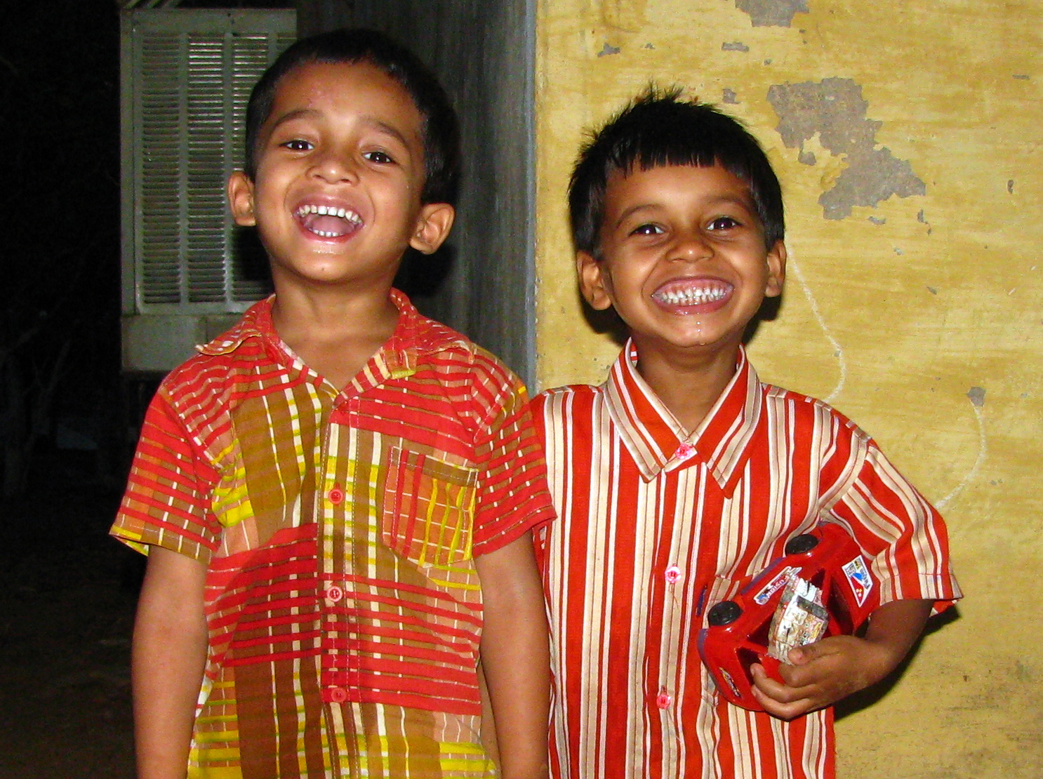
Generation next.

Village health workers: Chanda, vill Parsada; Ramala, vill Parsada; Gangabai, vill Piparkhunti; Baisakhiya, vill Piparkhunti; Tileshwarai, vill Piparkhunti; Gayatri, vill Shivterai; Sati, vill Shivterai; Bhagwati, vill Dawanpur; Janki, vill Manpur; Bhagwati, vill Karpiha; Hirmat, vill Karpiha; Basanta, vill Newsa; Ramshila, vill Newsa; Aghaniya, vill Mangalpur; Rita, vill Mangalpur; Bitawan Bai, vill Koripara; Kunwariya, vill Koripara; Mandakini, vill Saraipali; Usha, vill Saraipali; Santoshi, vill Karka; Itwara, vill Danokhar; Tija Bai, vill Danokhar; Itwara, vill Bandhipara; Munni Bai, vill Katami; Kaushalya, vill Katami; Kalabai, vill Bamhni, Belabai, vill Bamhni; Amarvati, vill Atariya; Shyamwati, vill Atariya; Parvati, vill Surhi; Urmila, vill Surhi; Rajmani, vill Surhi; Phulsita, vill Jakadbandha; Bundkunwer, vill Jakadbandha; Anusuiya, vill Jamunahi; Janki, vill Jamunahi; Indiya, vill Mahamai; Yashoda, vill Mahamai; Ramkali, vill Ghameri; Gulpati, vill Babutola; Binodini, vill Babutola; Rajkumari, vill Sarsoha; Shanti, vill Sarsoha; Birasiya, vill Daganiya; Bhagat, vill Daganiya; Jhurkali, vill Daganiya; Phulbai, vill Bisauni; Urmila, vill Niwaskhar; Itwariya, vill Niwaskhar; Anjana, vill Rajak; Sukkobai, vill Patparha; Baisakhiya, vill Boirha; Kamla Bai, vill Boirha; Janbai, vill Shantipur; Rajmani, vill Dongripara; Sanoshi, vill Semariya; Jhulbai, vill Aurapani; Phulbai, vill Aurapani; Satrupa, vill Majhgaon; Munni, vill Majhgaon; Shailendri, vill Jhingatpur; Chamarin, vill Jhingatpur; Kunwariya, vill Nawadih; Tulsibai, vill Nawadih; Pramila, vill Kekradih; Bibyani, vill Phulwaripara; Maino, vill Phulwaripara; Revati, vill Bade Barar; Ramli, vill Ratkhandi; Phulwkunwer, vill Ratkhandi; Pushpa, vill Chote Barar; Revati, vill Charpara; Vijaylakshmi, vill Charpara; Ganeshiya, vill Sripara; Meena, vill Sripara; Ahilya, vill Baigapara; Kamini, vill Kholipara; Ganeshiya, vill Kholipara; Shanti, vill Manjhipara (Semariya); Savni, vill Bahaoud; Shanti, vill Bahaoud; Kamla, vill Achanakmaar; Shyambai, vill Achanakmaar; Balkunwer, vill Achanakmaar; Ratni, vill Bankal; Santoshi, vill Samardhasan; Pusaiya, vill Sarasdol; Agheli, vill Siwalkhar; Munni, vill Siwalkhar; Drapuadi, vill Bindawal; Meghiya, vill Bindawal; Tiharin, vill Karhikachar; Lakshmi, vill Karhikachar; Panchobai, vill Chaparwa; Saraswati, vill Chaparwa; Sangita, vill Chaparwa; Rani, vill Tilaidabra.
Phulwari co-ordinators: Aghani Bai, vill Bamhni; Dulari Bai, vill Bamhni; Baisakhiya, vill Babutola; Kumari, vill Babutola; Maino, vill Babutola; Jamkunwer, vill Katami; Shakkar Bai, vill Katami; Ramshila, vill Katami; Dharmin, vill Katami; Indiya, vill Mahamai; Yasodha, vill Mahamai; Jaibai, vill Bisaunikhar; Kumaribai, vill Bisaunikhar; Joniha, vill Niwaskhar; Budhwariya, vill Niwaskhar; Bisahin Bai, vill Niwaskhar; Mati Bai, vill Sarsoha; Anita, vill Sarsoha; Premvati, vill Surhi; Kachra Bai, vill Surhi; Dukhiya, vill Surhi; Bisahin Bai, vill Surhi; Jagni, vill Surhi Dongripara; Manju, vill Surhi Dongripara; Birsa, vill Daganiya; Bigri, vill Daganiya; Rimso, vill Daganiya; Minka, vill Daganiya; Rajmati, vill Daganiya; Andhiyaro, vill Daganiya; Shyambai, vill Jamunahi; Anusuiya, vill Jamunahi; Sonia, vill Jamunahi; Savitri, vill Jamunahi; Raimuni, vill Jamunahi; Phulkumari, vill Jamunahi; Kaushalya, vill Atariya; Jantri Bai, vill Atariya; Sanmat, vill Atariya; Kunti, vill Atariya; Sona, vill Atariya; Shukwaria, vill Atariya; Sushilabai, vill Ghamerikhar; Kaushaliya Bai, vill Ghamerikhar; Tijmati, vill Ghamerikhar; Soniya, vill Jamunahi; Savitri, vill Jamunahi; Ishkumari, vill Rajak; Samari, vill Rajak; Bajarhin Bai, vill Boirha; Phulkumari, vill Jamunahi; Rammuni, vill Jamunahi; Anusuiya, vill Jamunahi; Phulmani, vill Jamunahi; Nemhanti, vill Jamunahi; Mangli, vill Jakadbandha; Vihani, vill Jakadbandha; Pardesh Bai, vill Karpiha; Rambai, vill Karpiha; Bismatia, vill Manpur; Satvantin, vill Dawanpur; Tijmati, vill Dawanpur; Jala Bai, vill Nevsa; Mahettarin, vill Nevsa; Shyamabai, vill Nevsa; Keja Bai, vill Nevsa; Ramhin, vill Baigapara; Jhanglin, vill Baigapara; Ganeshia, vill Karhikachar; Chandrika, vill Karhikachar; Parmeshwari, vill Karhikachar; Shivkumari, vill Karhikachar; Katika, vill Karhikachar (Baigapara); Budhwara Bai, vill Majhipara; Rambai, vill Jhingatpur; Ramphul, vill Jhingatpur; Sumitra, vill Ratkhandi; Manmati, vill Ratkhandi; Shanti, vill Semariya; Sonmat Bai, vill Semariya; Bilaso, vill Phulwaripara; Rajkumari, vill Bindawal; Meghiya Bai, vill Bindawal; Shambai, vill Bindawal; Mahetarin, vill Bindawal; Shambai, vill Bindawal; Sumitra, vill Bindawal; Ramphul, vill Bindawal; Panchkunwer vill Chhaparwa; Udasiya, vill Chhaparwa.

Present Executive Committee
Anurag Bhargava, MD; Binayak Sen, MD; BR Chatterjee, MD, President; C Sathyamala,, MBBS, MSc Epidemiology; Pramod Upadhyay, Ph.D; Raman Kataria, M.Ch, Secretary; Yogesh Jain, MD
-------------------------------------------------------

